TRAJECTORY TRACKING OF QUADROTOR
UNMANNED AERIAL VEHICLE USING PARTICLE
SWARM OPTIMIZATION BASED ADAPTIVE SUPER
TWISTING SLIDING MODE CONTROL
MUSA DAUD
MT300-0004/2023
MASTER OF SCIENCE IN MECHATRONIC
ENGINEERING
A Thesis submitted to Pan African University Institute
for Basic Sciences, Technology, and Innovation in partial
fulfilment of the requirement for the Award of the Degree
of Master of Science in Mechatronic Engineering
MAY 2026

DECLARATION
This thesis is my own work and has not been presented elsewhere for a degree
award in any university.
Signature . . . . . . . . . . . . . . . . . . . . . . . . . . . . . . . .Date . . . . . . . . . . . . . . . . . . . . . . . . . . . . . . . .
Musa Daud
MT300-0004/2023
This thesis has been submitted with our approval as university supervisors.
Signature . . . . . . . . . . . . . . . . . . . . . . . . . . . . . . . .Date . . . . . . . . . . . . . . . . . . . . . . . . . . . . . . . .
Dr.-Ing. Jackson Githu Njiri
JKUAT,Kenya.
Signature . . . . . . . . . . . . . . . . . . . . . . . . . . . . . . . .Date . . . . . . . . . . . . . . . . . . . . . . . . . . . . . . . .
Dr. Chala Merga Abdissa
Addis Ababa University-Ethiopia
i

DEDICATION
I dedicate this work to my beloved dad Mr. Daud Manhya Kasenga and fam-
ily, whose unwavering support, love, and encouragement have been my greatest
source of strength. A special dedication goes to my dear wife Mrs. Therezia Petro
Mathias, my son Riemann Musa Daud whose constant motivation, kindness and
belief in my abilities have inspired me to strive for excellence. Your unwavering
support has been a guiding light throughout this journey. This thesis is a tes-
tament to my family’s sacrifices, prayers, and unconditional love. I am forever
grateful.
ii

ACKNOWLEDGEMENT
I am profoundly grateful to Almighty God for His strength,wisdom and guidance
throughout this journey. I sincerely appreciate the African Union (AU) through
the Pan African University (PAU) for the scholarship to realize my academic as-
pirations. I extend my heartfelt gratitude to my research supervisors, Dr.-Ing.
Jackson Githu Njiri and Dr. Chala Merga Abdissa, for their invaluable guidance
and unwavering support. A special thanks goes to Dr. Rehema Ndeda, the me-
chanical and mechatronic engineering programmes coordinator at PAUSTI, for
her guidance and encouragement. A special thanks also goes to the Mbeya Uni-
versity of Science and Technology (MUST) for granting me a study leave. Lastly,
I am forever grateful to my family, friends, and colleagues for their unwavering
love and support, without which this achievement would not have been possible.
iii

TABLE OF CONTENTS
DECLARATION . . . . . . . . . . . . . . . . . . . . . . . . . . . . . . i
DEDICATION | . . . . . . . . . . . . . . . . . . . . . . . . . . . . . . . | ii
ACKNOWLEDGEMENT . . . . . . . . . . . . . . . . . . . . . . . . . iii
TABLE OF CONTENTS | . . . . . . . . . . . . . . . . . . . . . . . . . | iv
LIST OF TABLES . . . . . . . . . . . . . . . . . . . . . . . . . . . . . vii
LIST OF FIGURES | . . . . . . . . . . . . . . . . . . . . . . . . . . . . | xi
LIST OF APPENDICES . . . . . . . . . . . . . . . . . . . . . . . . . . xii
LIST OF ABBREVIATIONS | . . . . . . . . . . . . . . . . . . . . . . . | xiii

LIST OF NOMENCLATURES | . . . . . . . . . . . . . . . . . . . . . . | xiv
ABSTRACT . . . . . . . . . . . . . . . . . . . . . . . . . . . . . . . . xvii
1 | INTRODUCTION | 1

1.1 | Background . . . . . . . . . . . . . . . . . . . . . . . . . . . . . . | 1

1.2 | Statement of the Problem | . . . . . . . . . . . . . . . . . . . . . . | 2

1.3 | Objectives . . . . . . . . . . . . . . . . . . . . . . . . . . . . . . . | 3

1.4 | Justification and Scope . . . . . . . . . . . . . . . . . . . . . . . . | 3

1.5 | Structure of the Thesis . . . . . . . . . . . . . . . . . . . . . . . . | 4

2 | LITERATURE REVIEW | 5

2.1 | Introduction . . . . . . . . . . . . . . . . . . . . . . . . . . . . . . | 5

2.2 | Theoretical Background of Quadcopters UAVs . . . . . . . . . . . | 5

2.2.1 | Quadcopter Modelling Approaches | . . . . . . . . . . . . . | 5

2.3 | Critiques of existing literature relevant to the study . . . . . . . . | 17
iv

2.3.1 | Classical Control Strategies | . . . . . . . . . . . . . . . . . | 17

2.3.2 | Sliding Mode Control Techniques . . . . . . . . . . . . . . | 18

2.3.3 | Disturbance Observer-Based Approaches . . . . . . . . . . | 24

2.3.4 | Critical Analysis of Existing Super Twisting Controllers | . | 25

2.4 | The Research Gaps . . . . . . . . . . . . . . . . . . . . . . . . . . | 27

3 | METHODOLOGY | 29

3.1 | Introduction . . . . . . . . . . . . . . . . . . . . . . . . . . . . . . | 29

3.2 | Modeling and Analysis of Quadrotor Flight Dynamics . . . . . . . | 30

3.2.1 | Preliminary Notions of Quadrotor UAV . . . . . . . . . . . | 30

3.2.2 | Mathematical Modeling of Quadrotor Dynamics . . . . . . | 33

3.3 | Verification of Mathematical Model . . . . . . . . . . . . . . . . . | 48

3.4 | Design of Controller for Quadcopter . . . . . . . . . . . . . . . . . | 50

3.4.1 | Design of a quadrotor position controller . . . . . . . . . . | 52

3.4.2 | Attitude controller design | . . . . . . . . . . . . . . . . . . | 57

3.4.3 | SMC gain tuning . . . . . . . . . . . . . . . . . . . . . . . | 59

3.4.4 | Fitness function . . . . . . . . . . . . . . . . . . . . . . . . | 60

3.4.5 | Adaptive Super Twisting Sliding Mode Control design | . . | 63

3.5 | Controller Evaluation . . . . . . . . . . . . . . . . . . . . . . . . . | 66

4 | RESULTS AND DISCUSSION | 68

4.1 | Model Verification Results . . . . . . . . . . . . . . . . . . . . . . | 68

4.2 | PSO tunning results | . . . . . . . . . . . . . . . . . . . . . . . . . | 79

4.3 | Controller Evaluation Results . . . . . . . . . . . . . . . . . . . . | 80

4.3.1 | Parameter variation handling capacity . . . . . . . . . . . | 81

4.3.2 | Disturbance rejection capacity | . . . . . . . . . . . . . . . | 85

4.3.3 | Spiral infinity trajectory tracking . . . . . . . . . . . . . . | 89

4.3.4 | Ramp helix trajectory tracking | . . . . . . . . . . . . . . . | 93

4.3.5 | Square wave trajectory trajectory tracking . . . . . . . . . | 96
v

5 | CONCLUSION & RECOMMENDATIONS | 99

5.1 | Conclusion . . . . . . . . . . . . . . . . . . . . . . . . . . . . . . . | 99
5.2 Recommendations . . . . . . . . . . . . . . . . . . . . . . . . . . . 101
REFERENCES 110
vi

List of Tables
Table 3.1 | Specifications for the quadrotor model verification . . . | 48

Table 3.2 | Plant parameter | . . . . . . . . . . . . . . . . . . . . . | 65

Table 3.3 | Design parameters for PSO-SMC . . . . . . . . . . . . | 65

Table 3.4 | Design parameters for ASTSMC | . . . . . . . . . . . . | 65

Table 3.5 | Design parameters of adaptation law . . . . . . . . . . | 65
Table 4.1 PSO Performance for Different Numbers of Particles in
Attitude Gains Tuning . . . . . . . . . . . . . . . . . . 79
Table 4.2 PSO Performance for Different Numbers of Particles in
Position Gains Tuning . . . . . . . . . . . . . . . . . . 79
Table 4.3 | ITAE values during parametric variation . . . . . . . . | 84

Table 4.4 | Approximate convergence times under disturbance | . . | 86

Table 4.5 | ITAE values during disturbance rejection | . . . . . . . | 89
vii

List of Figures
Figure 1.1 Quadcopter designs: X-shaped (I4 and X4), H-shaped
(H4) . . . . . . . . . . . . . . . . . . . . . . . . . . . . 2
Figure 2.1 Quaternion representation of rotation along rotation
axis ˆu . . . . . . . . . . . . . . . . . . . . . . . . . . . 9
Figure 2.2 | Rigid body rotation in terms of axis-angle notation . . | 15

Figure 3.1 | Methodology Flow Chart | . . . . . . . . . . . . . . . . | 30
Figure 3.2 Types of quadcopter configurations showing motion gen-
eration through propeller speed variation: (a) hover
and pitch motion, (b) roll and yaw motion. | . . . . . . | 31

Figure 3.3 | Quadrotor free body diagram and its reference frames | 32
Figure 3.4 Per phase equivalent circuit of a trapezoidal BLDC mo-
tor | . . . . . . . . . . . . . . . . . . . . . . . . . . . . | 42
Figure 3.5 Controller architecture for quadrotor, including posi-
tion, altitude, and virtual control input designs . . . . 52
Figure 3.6 Diagram of position controller for maintaining quadro-
tor trajectory along x,y,and zaxes . . . . . . . . . . . . 55
Figure 3.7 Attitude controller diagram for maintaining desired quadro-
tor altitude . . . . . . . . . . . . . . . . . . . . . . . . 57
Figure 3.8 PSO algorithm flowchart used for tuning quadrotor slid-
ing surface parameters . . . . . . . . . . . . . . . . . . 60
viii

Figure 4.1 Quadrotor state for ascending maneuvering when U1 >
mg . . . . . . . . . . . . . . . . . . . . . . . . . . . . . 70
Figure 4.2 | At Hovering state when U1 = mg . . . . . . . . . . . . | 71

Figure 4.3 | Roll rotation due to U1 = mg and U2 = 0.2 Nm . . . . | 74

Figure 4.4 | Pitch rotation due to U1 = mg and U3 = 0.2 Nm | . . . | 76

Figure 4.5 | CW yaw rotation due to U1 = mg and U4 = 0.2 Nm | . | 78
Figure 4.6 Attitude ITAE against Number of Iterations for differ-
ent Particle Swarm Size . . . . . . . . . . . . . . . . . 80
Figure 4.7 Position ITAE against Number of Iterations for differ-
ent Particle Swarm Size . . . . . . . . . . . . . . . . . 80
Figure 4.8 | Position X tracking with parametric variation . . . . . | 83

Figure 4.9 | Position Y tracking with parametric variation . . . . . | 83

Figure 4.10 | Position Z tracking with parametric variation . . . . . | 83

Figure 4.11 | Yaw tracking with parametric variation | . . . . . . . . | 83

Figure 4.12 | Control input U1 during parametric variation . . . . . | 84

Figure 4.13 | Control input U2 during parametric variation . . . . . | 84

Figure 4.14 | Control input U3 during parametric variation . . . . . | 84

Figure 4.15 | Control input U4 during parametric variation . . . . . | 84

Figure 4.16 | Position X tracking with disturbance . . . . . . . . . . | 88

Figure 4.17 | Position Y tracking with disturbance . . . . . . . . . . | 88

Figure 4.18 | Position Z tracking with disturbance . . . . . . . . . . | 88

Figure 4.19 | Yaw tracking with disturbance | . . . . . . . . . . . . . | 88

Figure 4.20 | Control input U1 during disturbance . . . . . . . . . . | 88

Figure 4.21 | Control input U2 during disturbance . . . . . . . . . . | 88

Figure 4.22 | Control input U3 during disturbance . . . . . . . . . . | 88

Figure 4.23 | Control input U4 during disturbance . . . . . . . . . . | 88

Figure 4.24 | Spiral Infinity X Position Tracking . . . . . . . . . . . | 91

Figure 4.25 | Spiral Infinity Y Position Tracking . . . . . . . . . . . | 91
ix

Figure 4.26 | Spiral Infinity Z Position Tracking | . . . . . . . . . . . | 91

Figure 4.27 | Spiral Infinity Roll Angle Tracking . . . . . . . . . . . | 91

Figure 4.28 | Spiral Infinity Pitch Angle Tracking | . . . . . . . . . . | 91

Figure 4.29 | Spiral Infinity Yaw Angle tracking | . . . . . . . . . . . | 91

Figure 4.30 | Control input U1 for Spiral Infinity trajectory . . . . . | 92

Figure 4.31 | Control input U2 for Spiral Infinity trajectory . . . . . | 92

Figure 4.32 | Control input U3 for Spiral Infinity trajectory . . . . . | 92

Figure 4.33 | Control input U4 for Spiral Infinity trajectory . . . . . | 92

Figure 4.34 | Spiral Infinity 3D Position Tracking | . . . . . . . . . . | 92

Figure 4.35 | Ramp Helix X Position Tracking . . . . . . . . . . . . | 94

Figure 4.36 | Ramp Helix Y Position Tracking . . . . . . . . . . . . | 94

Figure 4.37 | Ramp Helix Z Position Tracking | . . . . . . . . . . . . | 94

Figure 4.38 | Ramp Helix Roll Angle Tracking . . . . . . . . . . . . | 94

Figure 4.39 | Ramp Helix Pitch Angle Tracking | . . . . . . . . . . . | 94

Figure 4.40 | Ramp Helix wave tracking | . . . . . . . . . . . . . . . | 94

Figure 4.41 | Control input U1 for Ramp Helix trajectory . . . . . . | 95

Figure 4.42 | Control input U2 for Ramp Helix trajectory . . . . . . | 95

Figure 4.43 | Control input U3 for Ramp Helix trajectory . . . . . . | 95

Figure 4.44 | Control input U4 for Ramp Helix trajectory . . . . . . | 95

Figure 4.45 | Ramp Helix 3D Position Tracking | . . . . . . . . . . . | 95

Figure 4.46 | Square wave X Position Tracking . . . . . . . . . . . . | 97

Figure 4.47 | Square wave Y Position Tracking . . . . . . . . . . . . | 97

Figure 4.48 | Square wave Z Position Tracking . . . . . . . . . . . . | 97

Figure 4.49 | Square wave Roll Angle Tracking . . . . . . . . . . . . | 97

Figure 4.50 | Square wave Pitch Angle Tracking | . . . . . . . . . . . | 97

Figure 4.51 | Yaw Square wave tracking | . . . . . . . . . . . . . . . | 97

Figure 4.52 | Control input U1 for square wave trajectory . . . . . . | 98

Figure 4.53 | Control input U2 for square wave trajectory . . . . . . | 98
x

Figure 4.54 | Control input U3 for square wave trajectory . . . . . . | 98

Figure 4.55 | Control input U4 for square wave trajectory . . . . . . | 98

Figure 4.56 | Square wave 3D Position Tracking | . . . . . . . . . . . | 98
xi

LIST OF APPENDICES
APPENDIX A: Github link for the PSO Algo-
rithm in MATLAB
https://github.com/MUSA1994DAUD/PSO-optimization
APPENDIX B: Github link for designed con-
troller in MATLAB/Simulink
https://github.com/MUSA1994DAUD/Adaptive-super-twisting-sliding-mode-controlle
ASTSMC Quadcopter GitHub Repository
APPENDIX C: Published Journal Article
The research conducted in this thesis resulted in the following published journal
article:
M. Daud and J. G. Njiri, “Trajectory tracking of quadrotor UAVs
using particle swarm optimized adaptive super twisting sliding mode
control,” Engineering, Technology & Applied Science Research, vol.
16, no. 3, pp. 34807–34816, 2026.
Available online at:
https://etasr.com/index.php/ETASR/article/view/17726
xii

LIST OF ABBREVIATIONS
ASMC Adaptive Sliding Mode Control
ASTSMC Adaptive Super Twisting Sliding Mode Control
BF Body Frame
BLDC Brushless Direct Current
DOF Degree of Freedom
ESC Electronic Speed Controller
FL Fuzzy Logic
FOPID Fractional Order Proportional Integral Derivative
GBEST Global Best Value of Optimization
GPS Global Positioning System
HOSM Higher Order Sliding Mode
IF Inertial Frame
ITAE Integral Time Absolute Error
LQR Linear Quadratic Regulator
MATLAB Matrix Laboratory
MPC Model Predictive Control
PID Proportional Integral Derivative
PSO Particle Swarm Optimization
PWM Pulse Width Modulation
SMC Sliding Mode Control
STA Super Twisting Algorithm
STSMC Super Twisting Sliding Mode Control
UAV Unmanned Aerial Vehicle
VTOL Vertical Take-Off and Landing
xiii

LIST OF NOMENCLATURES
Symbol | Description | Unit

x, y, z | Position of the quadrotor in inertial frame along | m
x-, y-, and z-axes
˙x, ˙y, ˙z | Linear velocity components along x-, y-, and z- | m/s
axes
¨x, ¨y, ¨z | Linear acceleration components along x-, y-, and | m/s2
z-axes
ϕ | Roll angle | rad

θ | Pitch angle | rad

ψ | Yaw angle | rad

p, q, r | Angular velocity components about body x-, y-, | rad/s
and z-axes
η | Euler angle vector, η = [ϕ θ ψ]⊤ | –

p | Position vector, p = [x y z]⊤ | m

v | Velocity vector, v = [ ˙x ˙y ˙z]⊤ | m/s

ω | Angular velocity vector, ω = [p q r]⊤ | rad/s

q0, q1, q2, q3 | Quaternion components describing attitude | –

q | Quaternion vector, q = [q0 q1 q2 q3]⊤ | –

U1 | Total thrust control input | N

U2 | Roll control torque | N m

U3 | Pitch control torque | N m

U4 | Yaw control torque | N m

W | Weight of the quadrotor | N

m | Mass of quadrotor | kg

g | Acceleration due to gravity | m/s2

ℓor l | Length of quadrotor arm | m
xiv

Symbol | Description | Unit

Jxx | Moment of inertia about body x-axis | N m s2

Jyy | Moment of inertia about body y-axis | N m s2

Jzz | Moment of inertia about body z-axis | N m s2

Jp | Rotor or propeller inertia | N m s2

R | Rotor or propeller radius | m

b | Thrust coefficient | N/m/s

d | Drag factor / drag coefficient | N m s2

Caϕ, Caθ, Caψ | Rotational drag coefficients | N/m/s

Cax, Cay, Caz | Translational drag coefficients | N/m/s

γ | Correction factor | –

ex, ey, ez | Translational tracking error | –

˙ex, ˙ey, ˙ez | Time derivative of tracking error | –

eq1, eq2, eq3 | Rotational tracking error | –

˙eq1, ˙eq2, ˙eq3 | Time derivative of rotational tracking error | –

σ | Sliding surface | –

λ | Sliding surface gain | –

u | Control input | –

ueq | Equivalent control input | –

usw | Super twisting control input | –

K | Switching gain | –

sign(σ) | Signum function of sliding variable | –

k1, k2 | Super twisting control gains | –

v | Auxiliary super twisting control term | –

˙v1 | Derivative of auxiliary super twisting term | –

λx, λy, λz | Position sliding surface gains | –

λq1, λq2, λq3 | Quaternion sliding surface gains | –
xv

Symbol | Description | Unit

cx, cy, cz | Position controller parameters | –

cq1, cq2, cq3 | Quaternion controller parameters | –

ax, ay, az | ASTSMC position parameters | –

aq1, aq2, aq3 | ASTSMC quaternion parameters | –

βx, βy, βz | ASTSMC adaptive gains for position channels | –

βq1, βq2, βq3 | ASTSMC adaptive gains for quaternion channels | –

ω1 | Adaptation law parameter | –

am | Adaptation law parameter | –

η | Adaptation law parameter | –

γ1 | Adaptation law gain | –

µ | Adaptation law parameter | –

uba | Upper bound for attitude gains | –

lba | Lower bound for attitude gains | –

ubp | Upper bound for position gains | –

lbp | Lower bound for position gains | –

vmax | Maximum particle swarm velocity coefficient | –

vmin | Minimum particle swarm velocity coefficient | –

c1 | First particle swarm acceleration coefficient | –

c2 | Second particle swarm acceleration coefficient | –
xvi

ABSTRACT
Quadrotor Unmanned Aerial Vehicles are increasingly used in search and res-
cue, agriculture, mapping, service delivery, military surveillance, and power line
inspection. However, their underactuated dynamics, coupled with parametric un-
certainties, unmodelled dynamics, and disturbances pose substantial challenges
for robust trajectory tracking and attitude stabilization.
Among others classical controllers including Proportional Integral Derivatives,
Model Predictive Control and Linear Quadratic Regulator offer acceptable perfor-
mance but lack robustness under disturbances, and parameter variations. Sliding
Mode Control overcomes key limitations of linear controllers with strong robust-
ness, however, its main weakness is chattering caused by discontinuous switching
control, which may excite unmodeled dynamics and wear actuator.
This work develops a quaternion based dynamic model for quadrotor motion
that captures both translational and rotational behavior. Unlike many existing
models, the proposed formulation includes unmodeled effects such as aerodynamic
drag and propeller induced forces, resulting in a more realistic and more accurate
representation of quadcopter flight dynamics.
An Adaptive Super Twisting Sliding Mode Controller (ASTSMC) based on quater-
nion modeling was designed such that quaternion representation ensures smooth
attitude tracking without gimbal lock, while Super Twisting reduces chattering
and improves robustness.
Particle Swarm Optimization (PSO) was used to tune the sliding surface gains of
the ASTSMC, reducing attitude objective values by 4.43%–27.22% with respect
to initial global best value and improving position accuracy by up to 10.62%.
The Best Global value drop from 10.49 to 7.66 reflects a 26.97% reduction in

combined tracking error and control effort. Gains tuned by PSO yield faster
xvii

convergence, smoother response, and better performance than manual tuning.
The proposed PSO ASTSMC significantly enhances quadrotor trajectory track-
ing by reducing attitude errors by up to 27% and improving position accuracy
by 0.61%–10.62% relative to a conventional PID and backstepping sliding mode
control under identical simulation conditions.
xviii

CHAPTER 1
INTRODUCTION
1.1 Background
An Unmanned Aerial Vehicles (UAVs) is an aircraft that is intended to fly without
a pilot onboard. It’s steering and flight control are handled by a dedicated control
station behind the aircraft or by a suitable program[1]. A quadcopter, also known
as a quadrotor, is one among other types of copter drone that are controlled by
four rotors. Each rotor is mounted at the end of a horizontal arm, and the
propellers generate lift by spinning in opposite directions (two rotors spin in
clockwise direction while other two rotors spin in anticlockwise direction).
Owing to features like simple design, better stability, and ease of control, they are
widely used compared to other types of UAVs [1]. Quadcopters have a symmet-
rical I-, X- or H-shaped or hybrid frame with four arms as shown in Figure 1.1,
each supporting a rotor. The rotors are arranged in a square or rectangular pat-
tern, and they can be independently controlled for stability and maneuverability.
The drone’s flight is controlled by adjusting the speed of each rotor, allowing it
to ascend, descend, rotate, and move horizontally
Unmanned Aerial Vehicle (UAV) quadcopters have diverse applications across
multiple industries due to their agility, stability, and ease of control. In agricul-
ture, they are used for crop monitoring, precision spraying, and pest control [2].
In surveillance and security, they assist in border patrol, disaster response, and
1

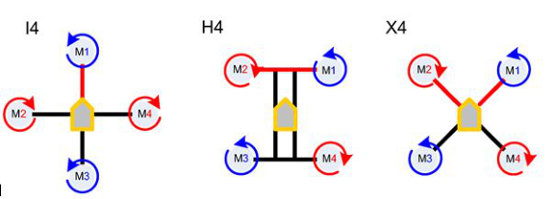

Figure 1.1: Quadcopter designs: Plus-shaped (I4),H-shaped (H4) and X-shaped (X4).
[1].
law enforcement operations [3]. Quadcopters also play a vital role in delivery
services, transporting medical supplies and consumer goods to remote areas [4].
In construction and infrastructure, they provide aerial mapping, site inspections,
and structural monitoring. Additionally, they are used in filmmaking, environ-
mental monitoring, and search and rescue missions, making them invaluable in
various fields [1]. However, their inherent underactuated dynamics, coupled with
parametric uncertainties, unmodelled dynamics, aerodynamic disturbances and
actuator nonlinearities, pose substantial challenges for robust trajectory tracking
and attitude stabilization, these challenges neccesitate the development of the
robust control strategies capable of ensuring stable flights and precise trajectory
tracking under adverse conditions.
1.2 Statement of the Problem
Quadrotor Unmanned Aerial Vehicles (UAVs) are nonlinear, underactuated, and
highly coupled systems affected by aerodynamic uncertainties, payload varia-
tions, external disturbances, and unmodeled dynamics. Conventional controllers
such as PID [5] and LQR [6] provide satisfactory performance under simplified
conditions but often lose robustness and tracking accuracy in uncertain nonlin-
ear environments. Sliding Mode Control (SMC) improves robustness but suf-
fers from chattering [7], [8], which may excite unmodeled dynamics and de-
grade control smoothness. Furthermore, many existing approaches rely on Euler-
2

angle modeling, which is prone to singularities during aggressive maneuvers [9],
whereas quaternion-based modeling provides singularity-free attitude representa-
tion. Although ASTSMC reduces chattering and improves robustness, its perfor-
mance strongly depends on proper gain tuning. Therefore, there is a need for a
quaternion-based PSO-tuned ASTSMC framework capable of handling uncertain-
ties and unmodeled dynamics while improving trajectory tracking and robustness
of quadrotor UAVs.
1.3 Objectives
The main objective of this research is to develop a Particle Swarm Optimized
based Adaptive Super Twisting Sliding Mode Control (PSO-ASTSMC) strategy
for a quadrotor Unmanned Aerial Vehicle that enhances trajectory tracking ac-
curacy and robustness against external disturbances and model uncertainties. To
achieve this objective the following specific objectives were realized.
i) To develop a non singular mathematical model of quadrotor free from gim-
bal lock.
ii) To develop an Adaptive Super Twisting Sliding Mode Control(ASMC)
based on adaptive sliding surface using PSO algorithm..
iii) To evaluate perfomance of designed controller by doing simulations.
1.4 Justification and Scope
This study develops a PSO-based Adaptive Super-Twisting Sliding Mode Con-
troller using quaternion modeling for robust quadrotor UAV control under un-
certainties and disturbances. Conventional Sliding Mode Controllers suffer from
chattering and poor adaptability, while Super-Twisting algorithms reduce chat-
3

tering but require proper gain tuning. To address this, Particle Swarm Optimiza-
tion is employed for gain tunning.
Quaternion representation eliminates singularities associated with Euler angles
and improves attitude description, while aerodynamic drag and propeller effects
enhance model accuracy. Controller performance is evaluated using trajectory
tracking error, settling time, rise time, overshoot, control effort, and Integral
Time Absolute Error , together with disturbance rejection capability. Lyapunov
stability analysis confirms closed-loop stability, while simulation results demon-
strate faster convergence, improved robustness, reduced chattering, and accurate
trajectory tracking.
1.5 Structure of the Thesis
The thesis is organized into five chapters including this introduction. Chapter
Two presents a review and analysis of related works to identify existing research
gaps in the literature. Chapter Three describes the research methodology, includ-
ing the derivation and verification of the nonlinear quadcopter dynamic model,
as well as the design and simulation-based validation of the proposed controller
for position, altitude, and attitude control in MATLAB/Simulink. Chapter Four
presents and discusses the simulation results obtained from the developed control
system. Finally, Chapter Five provides the conclusions of the study together with
recommendations for future work.
4

CHAPTER 2
LITERATURE REVIEW
2.1 Introduction
This chapter aims to provide a comprehensive and critical analysis of quadcopter
control strategies with emphasis on robust nonlinear methods, particularly Adap-
tive Super Twisting Sliding Mode Control (ASTSMC). The review systematically
examines mathematical modeling approaches, classical and advanced control tech-
niques, disturbance observer-based methods, and identifies critical limitations and
research gaps that justify the development of enhanced Adaptive Super Twisting
Sliding Mode Controllers incorporating unmodeled dynamics compensation.
2.2 Theoretical Background of Quadcopters UAVs
2.2.1 Quadcopter Modelling Approaches
Accurate mathematical modeling forms the foundation for effective control system
design. Quadcopter dynamics are typically described using rigid body mechanics,
with the choice of attitude representation significantly influencing controller de-
sign, computational complexity, and singularity issues. This section examines the
two predominant modeling approaches: Euler angle formulation and quaternion-
based formulation.
Euler angle modelling represents quadcopter attitude through three sequential
5

rotations roll (ϕ), pitch (θ), and yaw (ψ) that mathematically transform the
body frame to the inertial reference frame via rotation matrices [10, 11, 12].
The transformation from body angular velocities (p, q, r) to Euler angle rates is
expressed as
 | ˙ϕ |  | 1 | sin ϕ tan θ | cos ϕ tan θ |  | p

˙θ  ˙ψ |  | = | 0  0 | cos ϕ | −sin ϕ |  |  | q |  | (2.1)
 |  |  |  | sin ϕ | cos ϕ |  |  | r |  | (2.1)
 |  |  |  | cos θ | cos θ
The corresponding rotation matrix from the body frame to the inertial frame is
given by
 | cψcθ | cψsθsϕ −sψcϕ | cψsθcϕ + sψsϕ | 

R = | sψcθ  −sθ | sψsθsϕ + cψcϕ | sψsθcϕ −cψsϕ  cθcϕ  | (2.2)
R = | sψcθ  −sθ | cθsϕ | sψsθcϕ −cψsϕ  cθcϕ  | (2.2)
where c(.) = cos(.) and s(.) = sin(.). This parametrization establishes a nonlinear
dynamic model that captures the six degree of freedom motion of quadcopters [13,
14].
The approach offers several merits from a control engineering perspective. Euler
angles provide physical intuitiveness, directly corresponding to observable roll,
pitch, and yaw motions [15], and their simplicity facilitates straightforward im-
plementation in classical control architectures [16, 13]. Linearization around the
hover equilibrium point, justified by small angle assumptions, reduces the trans-
formation matrix to identity [17], enabling compatibility with PID and linear
quadratic regulators for stabilization tasks [5, 6, 13].
However, significant demerits constrain their applicability. The transformation
matrix in (2.1) becomes singular when cos(θ) = 0, which occurs at θ = ±90◦[10,
6

11]. This phenomenon leads to gimbal lock, a fundamental singularity that pre-
vents unique attitude representation [18, 19]. This limitation renders Euler angles
unsuitable for aggressive maneuvers requiring large attitude excursions [20, 18].
Additionally, the rotational dynamics exhibit strong nonlinear coupling between
axes [21, 22], and linearized models break down when the vehicle diverges from
operating points [22].Numerical instability at large angles and the inability to
accommodate unmodeled dynamics such as payload variations further restrict
Euler-based controllers [19], motivating alternative representations like quater-
nions for applications demanding robust performance across the full attitude
space [18, 19].
To overcome the singularity issues associated with Euler angles, quaternion based
representations have been increasingly adopted in recent quadcopter control re-
search. Quaternions are four dimensional unit vectors that provide a singularity
free, globally valid description of three dimensional rotations [23, 24].
Coordinate frames transformation is used to transform quantities between the
two reference frames. In this subsection the Quaternion approach for coordinate
transformation is realized as controller designed based on this. The concept
of quaternions was originally introduced by W.R. Hamilton in 1843 [25] as an
extension of complex numbers to higher dimensions. Hamilton recognized that
complex numbers provide an elegant framework for representing rotations in two-
dimensional space and hypothesized that a generalization to higher dimensions
would similarly facilitate rotation operations in three-dimensional space.
Consequently, quaternions emerge as hypercomplex numbers comprising four di-
mensions one real component and three imaginary components which effectively
circumvent the nonlinearity, geometric singularities, and computational complex-
ity typically associated with Euler angle representations [26, 27]. A quaternion
consists of a scalar part q0 and a three-dimensional vector part ⃗q = [q1, q2, q3],
7

which can be expressed in the form:
q = (q0, ⃗q) = | cosθ2, sin θ2 ˆu | , | (2.3)
where θ represents the rotation angle and ˆu is the unit vector along the rotation
axis.The vector part is defined with respect to an orthonormal basis [ˆi,ˆj,ˆk] rep-
resenting the [x, y, z] coordinate axes, respectively. These basis elements satisfy
the fundamental multiplication rules introduced by W.R. Hamilton [25]:
ij = k = −ji, | jk = i = −kj, | ki = j = −ik. | (2.4)
From these rules, it follows that:
i2= j2= k2= ijk = −1. (2.5)
There are three equivalent conventions commonly used for representing a quater-
nion:
q = q0 + q1ˆi + q2ˆj + q3ˆk = [q0, q1, q2, q3] = (q0, ⃗q). (2.6)
For valid representation of 3D orientations and vector rotations, quaternions must
be normalized. Normalized quaternions provide an optimal framework for de-
scribing object orientations in three-dimensional space and transforming coordi-
nates between reference frames. Normalization follows the standard procedure for
four-dimensional vectors, dividing each component by the quaternion’s Euclidean
norm:
q =q0 + q1ˆi + q2ˆj + q3ˆk  q2 0+ q2 1+ q2 2+ q2 | . | (2.7)
The normalized quaternion physically represents a single rotation about an axis
ˆu in 3D space, defining the orientation of a frame relative to a reference frame
8

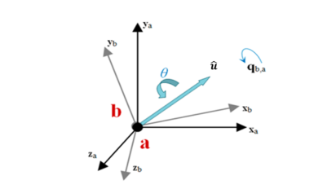

as shown in Figure 2.1). This contrasts with Euler’s rotation theorem, which
requires three consecutive rotations about individual axes (yaw, pitch, and roll).
Figure 2.1: Quaternion representation of rotation along rotation axis ˆu
Given their elegant mathematical properties, unit quaternions are employed to
derive the quadrotor dynamic model. In the unit quaternion representation shown
in Equation 2.3, the scalar component q0 = cos(θ/2) encodes the rotation angle,
while the vector component ⃗q = sin(θ/2)ˆu specifies the rotation axis direction,
where ˆu is the unit vector:
ˆu = | ⃗q | (2.8)
ˆu = | ∥⃗q∥. | (2.8)
Quaternions utilize a specialized multiplication operator called the quaternion
product, denoted by ‘⊗’, which is fundamental to vector transformations and
rotational kinematics. For two quaternions qa = (q0a, ⃗qa) and qb = (q0b, ⃗qb), the
product is defined as:
qa ⊗qb = (q0aq0b −⃗qa · ⃗qb, q0a⃗qb + q0b⃗qa + ⃗qa × ⃗qb) . (2.9)
Coordinate transformations between reference frames are performed using quater-
nion rotation [28]:
X = q ⊗X′⊗q∗, (2.10)
where X′is the vector in the original frame, X is the transformed vector, and
q∗denotes the quaternion conjugate. For unit quaternions (∥q∥= 1), the inverse
9

equals the conjugate, since:
q−1= | ∥q∥2 = q∗1 = q∗. | (2.11)
An important property of quaternions is that the product of two or more rotation
quaternions yields another rotation quaternion representing the cumulative effect
of applying each individual rotation sequentially. This compositional property
makes quaternions particularly efficient for representing complex orientation se-
quences. To transform vectors between reference frames, they are first expressed
as pure quaternions quaternions with zero scalar components.
A vector ri = [xi, yi, zi]Tin the inertial frame (IF) is represented as the pure
quaternion (0, ri). The transformation to the body frame (BF) is then computed
as: |  | 0 |  |  | 0 | 

rb | = q ⊗ | ri | ⊗q∗, | (2.12)
where q = (q0, q1, q2, q3) is the unit quaternion representing the body orientation
relative to the inertial frame, and q∗= (q0, −q1, −q2, −q3) denotes its conjugate.
The transformation is evaluated through two successive quaternion multiplica-
tions.
 | 0 | 

First multiplication: | w = q ⊗ | ri |  | Define the vector components v1 =
[q1, q2, q3]Tand v2 = [xi, yi, zi]T. Applying the quaternion product formula (Equa-
tion 2.9):
(q0, v1) ⊗(0, v2) = (q0 · 0 −v1 · v2, q0v2 + 0 · v1 + v1 × v2), (2.13)
10

which simplifies to:
w = (−v1 · v2, q0v2 + v1 × v2). (2.14)
The required dot and cross products are:
v1 · v2 = q1xi + q2yi + q3zi, (2.15)
 | q2zi −q3yi | 

v1 × v2 = | q1yi −q2xi q3xi −q1zi |  | . | (2.16)
Substituting these yields the intermediate quaternion w = (w0, w):
−(q1xi + q2yi + q3zi)
w = |  | q0xi + q2zi −q3yi |  | . | (2.17)
w = |  | q0yi + q3xi −q1zi |  | . | (2.17)
w = |  | q0zi + q1yi −q2xi |  | . | (2.17)

Second multiplication: | rq b= w ⊗q∗ | . | The final transformation is ob-
tained by multiplying the intermediate quaternion w with the conjugate q∗=
(q0, −q1, −q2, −q3): |  | 0 | 

rb | = w ⊗q∗. | (2.18)
This second quaternion product, evaluated using Equation 2.9, yields the rotated
vector rb in the body frame. The scalar component of the result is zero, confirming
that the output is a pure quaternion representing the transformed vector. To
complete the transformation rq b= w⊗q∗, we apply the quaternion product formula
11

to w = (w0, w) and q∗= (q0, −q):
w ⊗q∗= (w0q0 −w · q, w0q + q0w + w × q), (2.19)
where q = [q1, q2, q3]T.
Using w0 = −(q1xi + q2yi + q3zi) and w = [q0xi + q2zi −q3yi, q0yi + q3xi −
q1zi, q0zi + q1yi −q2xi]T:
w0q0 = −q0(q1xi + q2yi + q3zi), (2.20)
w · (−q) = −(q0xi + q2zi −q3yi)(−q1) −(q0yi + q3xi −q1zi)(−q2)
−(q0zi + q1yi −q2xi)(−q3)
= q0(q1xi + q2yi + q3zi). (2.21)
Therefore, the scalar part vanishes,confirming the result is a pure quaternion:
w0q0 −w · q = 0, (2.22)
The vector part comprises three terms: w0(−q) + q0w + w × (−q).
Term 1: w0(−q)
−q1 |  | q2 1xi+ q1q2yi+ q1q3zi | 

w0(−q) = −(q1xi + q2yi + q3zi) | −q3  −q2 |  | = | q1q2xi + q2 2yi+ q2q3zi  q1q3xi + q2q3yi + q2 3zi |  | . | (2.23)
12

Term 2: q0w
q0xi + q2zi −q3yi |  | q2 0xi+ q0q2zi−q0q3yi | 

q0w = q0 | q0yi + q3xi −q1zi  q0zi + q1yi −q2xi |  | = | q2 0yi+ q0q3xi−q0q1zi  q2 0zi+ q0q1yi−q0q2xi |  | . | (2.24)
Term 3: w × (−q)
q0xi + q2zi −q3yi |  | −q1 |  | q2 2xi+ q1q2yi+ q1q3zi−q2 3xi+ q0q2zi−q0q3yi | 

w×(−q) = | q0yi + q3xi −q1zi  q0zi + q1yi −q2xi | ×   −q3 −q2 |  | = | q1q2xi + q2 3yi+ q2q3zi−q2 1yi+ q1q3xi−q0q1zi  q1q3xi + q2q3yi + q2 3zi−q2 2zi+ q0q1yi−q0q2xi |  | .
(2.25)
Summing the three terms and collecting coefficients of xi, yi, and zi:
(q2 0+ q2 1−q2 2−q2 3)xi+ 2(q1q2−q0q3)yi+ 2(q1q3+ q0q2)zi | 

rb = | 2(q1q2 + q0q3)xi + (q2 0−q2 1+ q2 2−q2 3)yi+ 2(q2q3−q0q1)zi  2(q1q3 −q0q2)xi + 2(q2q3 + q0q1)yi + (q2 0−q2 1−q2 2+ q2 3)zi |  | . | (2.26)
This can be expressed in matrix form as:
rb = Ri→b  q | ri, | (2.27)
where:
q2 0+ q2 1−q2 2−q2 | 2(q1q2 −q0q3) | 2(q1q3 + q0q2) | 

Ri→b  q | = |  | 2(q1q2 + q0q3) | q2 0−q2 1+ q2 2−q2 | 2(q2q3 −q0q1) |  | . | (2.28)
Ri→b  q | = |  | 2(q1q3 −q0q2) | 2(q2q3 + q0q1) | q2 0−q2 1−q2 2+ q2 |  | . | (2.28)
13

Simplified Form Using Unit Quaternion Property
For unit quaternions, ∥q∥2= q2 0+ q2 1+ q2 2+ q2 3= 1. This allows simplification of
the diagonal elements:
q2 0+ q2 1−q2 2−q2 3= q2 0+ q2 1−(1 −q2 0−q2 1) = 2(q2 0+ q2 1) −1, | (2.29)

q2 0−q2 1+ q2 2−q2 3= q2 0+ q2 2−(1 −q2 0−q2 2) = 2(q2 0+ q2 2) −1, | (2.30)

q2 0−q2 1−q2 2+ q2 3= q2 0+ q2 3−(1 −q2 0−q2 3) = 2(q2 0+ q2 3) −1. | (2.31)
Therefore, the quaternion-based rotation matrix from IF to BF simplifies to:
xb |  | 2(q2 0+ q2 1) −1 | 2(q1q2 −q0q3) | 2(q1q3 + q0q2) |  | xi | 

 | yb |  | = |  | 2(q1q2 + q0q3) | 2(q2 0+ q2 2) −1 | 2(q2q3 −q0q1)  2(q2 0+ q2 3) −1 |  | yi |  | (2.32)
 | zb |  | = |  | 2(q1q3 −q0q2) | 2(q2q3 + q0q1) | 2(q2q3 −q0q1)  2(q2 0+ q2 3) −1 |  | zi |  | (2.32)
Even though thrust generated from each propeller is measured with respect to
BF, Newton laws are valid on IF only. Hence, we need the rotation matrix that
projects BF into IF. Since the rotation matrix is orthogonal (determinant ±1),
the inverse equals its transpose. Therefore, the rotation matrix which projects
the BF quantities into IF now becomes:
xi |  | 2(q2 0+ q2 1) −1 | 2(q1q2 + q0q3) | 2(q1q3 −q0q2) |  | xb | 

 | yi |  | = |  | 2(q1q2 −q0q3) | 2(q2 0+ q2 2) −1 | 2(q2q3 + q0q1)  2(q2 0+ q2 3) −1 |  | yb |  | (2.33)
 | zi |  |  |  |  |  |  |  | zb |  | (2.33)
 |  |  |  |  | 2(q1q3 + q0q2) | 2(q2q3 −q0q1)
Compared to the Euler rotation matrix the quaternion rotation matrix in (2.33)
is more compact, efficient, and numerically stable. Relationship between axis
angle representation θ (shown in Figure2.2) and quaternion, derived from Eqn.
(2.3) and the exponential map, is:
14

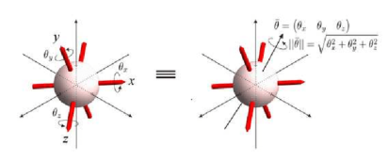

q = (q0, ⃗q) = | cosθ2, sin θ2 ˆu | = e | ¯θˆu | ¯θ | (2.34)
q = (q0, ⃗q) = | cosθ2, sin θ2 ˆu | = e | 2 = e | 2 | (2.34)
with
¯θ = 2 ln q. (2.35)
Figure 2.2: Rigid body rotation in terms of axis-angle notation [28].
And to get body frame velocity ω let’s take derivative of equation (2.35) from
both sides:
ω =d¯θdt= d dt(2 ln q) = 2 · 1 q⊗˙q = 2q−1 ⊗˙q | (2.36)
Then by multiplying both sides with1 2q we have.
˙q =1 2q ⊗ω = 1 | (q0, ⃗q) ⊗(0, ω) | =1 | (q0 ∗0 −⃗q · ω, q0 ∗ω + 0 ∗⃗q + ⃗q × ω) | (2.37)
˙q =1 2q ⊗ω = 1 | (q0, ⃗q) ⊗(0, ω) | 2 | (q0 ∗0 −⃗q · ω, q0 ∗ω + 0 ∗⃗q + ⃗q × ω) | (2.37)

    ˙q0 = −1 2⃗q · ⃗ω |  | (2.38)
     | ˙⃗q = 1 2 (q0⃗ω + ⃗q × ⃗ω) | (2.38)
Where ω = [p, q, r]Tis angular velocity in BF.
By expanding equation (2.38), we can obtain the following equations for quater-
nion rates:
15

˙q0 = −1 2 [q1 q2 q3] · [p q r]T = −1 2(pq1 + qq2 + rq3) | (2.39)

pq0 + rq2 −qq3 | 

˙⃗q = 1 2 (q0ω + ⃗q × ω) = 1 | qq0 + pq3 −rq1  rq0 + qq1 −pq2 |  | (2.40)
Hence, relation between quaternion rates and BF angular velocities is summarized
as | ˙q0 |  | q0 | −q1 | −q2 | −q3 |  | 0 | 

˙q1  ˙q2  ˙q3 |  | =1 | q1  q2  q3 | q0 | −q3 | q2 |  | p  q  r |  | (2.41)
˙q1  ˙q2  ˙q3 |  | 2 | q1  q2  q3 | q3 | q0 | −q1
 |  |  |  | −q2 | q1 | q0

Where : | p | 1 | 0 | −sθ |  |  | ˙ϕ | 

 | q |  | = | 0  0 | cϕ | sϕcθ |  | ˙θ  ˙ψ |  | (2.42)
 | r
 |  |  |  |  | −sϕ | cϕcθ
thus avoiding the trigonometric singularities present in Euler angle kinematics.
The quaternion representation offers several advantages. It is singularity free,
meaning there is no gimbal lock or coordinate singularities. Quaternions pro-
vide computational efficiency through fewer trigonometric operations compared
to rotation matrices. They also exhibit superior numerical stability with better
conditioning for numerical integration. Additionally, quaternions offer a compact
representation using only four parameters instead of the nine required for rotation
matrices.
In [9] Newton Quaternion formalism is employed for quadcopter modeling, em-
phasizing its singularity free nature and suitability for aggressive trajectory track-
16

ing. Similarly, in [29] a comprehensive quaternion based sliding mode control
framework for six degree of freedom flight control was developed, demonstrat-
ing improved performance in aggressive maneuvers.In [30] proposed quaternion
based adaptive backstepping and fast terminal sliding mode control strategies,
proving finite time convergence and robustness against unknown time varying
uncertainties. Furthermore, in [31] quaternion modeling was utilized to eliminate
singularity and gimbal lock problems in fault tolerant attitude control design.
2.3 Critiques of existing literature relevant to
the study
2.3.1 Classical Control Strategies
Classical control techniques have been extensively applied to quadcopter systems
due to their simplicity, ease of implementation, and well established theoreti-
cal foundations. This section reviews the most commonly employed classical
controllers PID and LQR and critically analyzes their limitations in handling
uncertainties and disturbances.
Proportional Integral Derivative (PID) control remains one of the most widely
used strategies in quadcopter systems due to its simplicity, ease of implemen-
tation, and satisfactory performance in near-hover conditions. It is commonly
implemented in cascaded architectures, where inner loops regulate angular rates
and outer loops control attitude and position [32, 33]. Variants such as Fractional
Order PID (FOPID) have been proposed to enhance flexibility and disturbance
rejection through additional tuning parameters [34].
Despite these advantages, PID controllers exhibit inherent limitations when ap-
plied to highly nonlinear quadcopter dynamics. Their reliance on linearized mod-
els restricts robustness under large operating deviations, parametric uncertain-
17

ties, and unmodeled dynamics [35]. Furthermore, PID control provides limited
rejection of time-varying disturbances and does not explicitly address the strong
coupling between translational and rotational dynamics [36, 37]. Consequently,
advanced nonlinear and adaptive control strategies have been shown to outper-
form PID in terms of tracking accuracy and disturbance rejection under challeng-
ing conditions [38, 39].
Linear Quadratic Regulator (LQR) is an optimal control technique that minimizes
a quadratic cost function representing a trade off between state regulation and
control effort. Linear Quadratic Regulator design requires a linear state space
model, typically obtained through linearization around hover or trim conditions.
The optimal feedback gain matrix is computed by solving the algebraic Riccati
equation. While LQR provides systematic gain selection based on optimization
criteria and guarantees stability for the linearized system, it shares similar limita-
tions with PID control regarding robustness to model uncertainties and external
disturbances.
The performance of LQR controllers degrades significantly when the system oper-
ates far from the linearization point or experiences substantial parametric varia-
tions [40, 41]. Recent literature on quadcopter control has shown limited focus on
pure LQR approaches, with researchers increasingly favoring nonlinear and adap-
tive techniques. This trend reflects the recognition that linear control methods
are fundamentally inadequate for addressing the challenges posed by quadcopter
dynamics under realistic operating conditions.
2.3.2 Sliding Mode Control Techniques
Sliding Mode Control (SMC) represents a powerful robust control methodology
capable of handling matched uncertainties and disturbances through discontinu-
18

ous control action. This section examines the fundamentals of SMC, Backstep-
ping Sliding Mode Control (BTSMC), Higher Order Sliding Mode variants, and
the Adaptive Super Twisting Sliding Mode Controller (ASTSMC), with critical
analysis of their performance characteristics.
Sliding Mode Control is based on the concept of constraining system trajectories
to a predefined sliding surface in the state space, where desired dynamic behavior
is achieved. The control law consists of two components: an equivalent control
that maintains motion on the sliding surface, and a switching control that drives
trajectories toward the surface [42, 37]. For a general nonlinear system, the sliding
surface is typically defined as
s = λe + ˙e (2.43)
where e is the tracking error and λ is a positive design parameter. The control
law takes the form
u = ueq + usw (2.44)
where ueq is the equivalent control and usw is the switching control, often imple-
mented as
usw = −K sign(s) (2.45)
The discontinuous signum function sign(s) provides robustness by forcing the
system states toward the sliding surface even in the presence of external distur-
bances and model uncertainties. This switching action continuously compensates
for parameter variations and unmodelled dynamics, thereby maintaining stable
19

tracking performance; however, it introduces the chattering phenomenon char-
acterized by high-frequency oscillations in the control signal [42, 8]. In [7], a
robust SMC algorithm for attitude and altitude stabilization of quadrotor UAVs
was designed, replacing the switching function with a smooth error function to
reduce chattering influences.
The study demonstrated that the proposed controller outperformed traditional
SMC, PID, and LQR controllers under parameter uncertainties and disturbances.
Similarly, in [8], a sliding mode controller based on Newton-Euler formulation was
developed and validated through MATLAB/Simulink simulations under distur-
bance conditions, although chattering reduction remained a challenge.
Backstepping Sliding Mode Control (BTSMC) combines the recursive stabiliza-
tion capability of backstepping control with the robustness of Sliding Mode Con-
trol. In BTSMC, the Backstepping procedure is first employed to derive virtual
control laws for each subsystem recursively, while the Sliding Mode component
is incorporated to improve robustness against uncertainties and external distur-
bances.
For quadcopter systems, BTSMC typically defines a tracking error as
e = x −xd (2.46)
where xd is the desired state and x is the actual state. A stabilizing virtual
control is then designed recursively using Lyapunov theory. The sliding surface
is commonly defined as
s = ˙e + λe (2.47)
The BTSMC control law combines the backstepping equivalent control with a
20

discontinuous switching term as
u = ub −K sign(s) (2.48)
where ub denotes the backstepping-based equivalent control component and K is
the switching gain.
The integration of Backstepping with Sliding Mode Control improves trajectory
tracking and enhances robustness compared to classical SMC. Backstepping pro-
vides systematic Lyapunov-based controller synthesis, while sliding mode action
compensates for matched disturbances and uncertainties. Several studies reported
improved stabilization and tracking performance using BTSMC for quadrotor sys-
tems under moderate disturbances.
Despite these advantages, BTSMC still exhibits important limitations. The dis-
continuous switching term introduces residual chattering, which may excite actu-
ator dynamics and reduce actuator lifespan. In addition, recursive backstepping
design significantly increases mathematical complexity, especially for highly non-
linear coupled systems such as quadrotors. Most BTSMC approaches also rely
on Euler-angle-based formulations, making them susceptible to singularities and
degraded performance during aggressive maneuvers involving large rotational an-
gles. Furthermore, the controller gains are often selected manually, reducing
adaptability under varying operating conditions.
In [37], a Proportional Integral Derivative Sliding Mode Control (PID-SMC) tech-
nique was proposed for attitude and position tracking of a quadcopter. The
method integrates PID control with Sliding Mode Control to enhance tracking
performance and robustness. To address unknown disturbance bounds, an adap-
tive PID-SMC scheme was developed, where adaptive laws were employed to

estimate disturbance limits in real time. Lyapunov stability analysis demon-
21

strated finite-time convergence of the closed-loop system for the full 6-DOF UAV
dynamics under external disturbances.
Simulation results indicated improved tracking accuracy and robustness com-
pared to conventional PID control. However, the proposed approach still relied on
Euler-angle-based modeling, which is susceptible to singularities and limits per-
formance under large-angle maneuvers. Additionally, the discontinuous switching
component introduced residual chattering, while the adaptive laws increased com-
putational complexity for real-time implementation.
To address chattering while maintaining robustness, Higher-Order Sliding Mode
(HOSM) techniques were developed. The HOSM controllers act on higher-order
derivatives of the sliding variable, allowing continuous control signals while pre-
serving finite-time convergence and disturbance rejection [9, 43]. Second-Order
Sliding Mode Control has attracted significant attention for quadcopter appli-
cations because it forces both the sliding surface and its derivative to zero in
finite time while reducing high-frequency switching [36, 9]. The Super Twisting
Algorithm (STA) is the most widely adopted Second-Order Sliding Mode tech-
nique due to its ability to achieve finite-time convergence using continuous control
action while requiring only the sliding variable [44, 36, 9].
The standard STA control law is expressed as
u = −k1|s|1/2sign(s) + u1 (2.49)
˙u1 = −k2sign(s) (2.50)
where k1 and k2 are positive gains satisfying conditions related to disturbance
bounds and their derivatives [44, 36, 9].
22

Adaptive Super Twisting Sliding Mode Control (ASTSMC) extends the standard
STA by introducing adaptive laws that automatically tune controller gains on-
line according to system behavior and disturbance conditions. Unlike BTSMC,
ASTSMC achieves continuous control action while preserving finite-time conver-
gence and strong robustness properties.
The ASTSMC control law is generally expressed as
u = −a|s|1/2sign(s) + ν (2.51)
˙ν = −β sign(s) (2.52)
where a and β are adaptive gains adjusted in real time. The adaptive mechanism
allows the controller to respond effectively to parameter uncertainties and external
disturbances without requiring precise prior knowledge of disturbance bounds.
Compared to BTSMC, ASTSMC offers several important advantages. First, the
continuous nature of the super twisting algorithm significantly reduces chatter-
ing compared to the discontinuous switching action in BTSMC. Second, adaptive
gain tuning improves robustness and adaptability under varying operating con-
ditions. Third, the use of quaternion-based modeling eliminates the singularity
and gimbal lock problems associated with Euler-angle formulations commonly
used in BTSMC approaches. These properties make ASTSMC more suitable for
aggressive quadcopter maneuvers and highly nonlinear flight conditions.
In [36], a robust Super Twisting Integral Sliding Mode Controller integrating the
STA with a modified PID-based sliding surface was proposed. The study demon-
strated improved trajectory tracking and significant chattering reduction under
time-varying disturbances, with Lyapunov analysis confirming system stability.
23

However, the approach relied on Euler-Newton modeling, which is susceptible to
singularities during large-angle maneuvers.
In [44], a Super Twisting Sliding Mode Controller incorporating a fuzzy PID-
based sliding surface demonstrated improved tracking accuracy, enhanced ro-
bustness, and significant chattering reduction through automatic gain tuning.
However, the performance depended heavily on heuristic selection of membership
functions and rule bases, limiting reproducibility and scalability.
In [9, 45], a nonsingular Adaptive Super Twisting Sliding Mode Controller based
on Newton-quaternion modeling was proposed. The study demonstrated im-
proved tracking accuracy and robust disturbance rejection through adaptive laws
and PSO-based gain optimization, with Lyapunov analysis ensuring system sta-
bility. However, aerodynamic forces and torques were neglected, limiting accuracy
under real flight conditions and aggressive maneuvers.
From the reviewed literature, it is evident that BTSMC improves robustness and
stabilization compared to conventional SMC but still suffers from residual chat-
tering, Euler-angle singularities, and increased computational complexity. On
the other hand, ASTSMC provides continuous control action, adaptive gain tun-
ing, reduced chattering, and singularity-free quaternion-based attitude represen-
tation. Nevertheless, existing ASTSMC studies still show limited consideration
of aerodynamic nonlinearities and real-world implementation constraints, thereby
motivating further investigation in this research.
2.3.3 Disturbance Observer-Based Approaches
Disturbance observers provide explicit estimation of external disturbances and
unmodeled dynamics, enabling feedforward compensation that enhances control
performance. This section examines disturbance observer design principles and
24

their integration with sliding mode and adaptive control techniques.
Disturbance observer-based control has emerged as an effective strategy for en-
hancing robustness in quadcopter systems by estimating and compensating un-
known disturbances in real time [39, 46, 47]. Existing studies demonstrate that
integrating disturbance observers with advanced control frameworks significantly
improves trajectory tracking accuracy, response speed, and disturbance rejec-
tion. For instance, dual-channel disturbance rejection architectures and observer-
assisted sliding mode controllers effectively handle both matched and mismatched
uncertainties, achieving superior performance compared to classical approaches [39,
46].
However, these methods introduce inherent design trade-offs. Disturbance esti-
mation accuracy degrades under fast time-varying disturbances, while high ob-
server gains required for rapid estimation may induce chattering and amplify noise
sensitivity. Additionally, reliance on nominal models limits robustness against
significant modeling errors, and tuning parameters such as observer gains and
differentiator speeds remains challenging. These limitations highlight the need
for more adaptive and computationally efficient disturbance compensation strate-
gies suitable for real-time applications.
2.3.4 Critical Analysis of Existing Super Twisting Con-
trollers
Despite significant advances in super twisting sliding mode control for quad-
copters, several critical limitations persist in existing approaches. This section
provides a detailed analysis of these limitations, focusing on unmodeled dynamics,
aerodynamic effects, actuator nonlinearities, and chattering phenomena.
Existing studies highlight that neglecting aerodynamic effects and payload varia-
25

tions significantly degrades quadcopter control performance under realistic condi-
tions [38, 43, 42]. Controllers incorporating adaptive estimation of aerodynamic
parameters and load dynamics demonstrate improved tracking accuracy, robust-
ness, and constraint handling compared to conventional approaches. These meth-
ods confirm the critical role of modeling uncertainties such as drag and payload-
induced variations. However, many super-twisting sliding mode controllers still
rely on simplified models and do not explicitly compensate for unmodeled dynam-
ics, including rotor aerodynamics and structural effects [36, 44]. This limitation
reduces their reliability and effectiveness in real-world applications, where such
dynamics are unavoidable and significantly influence system behavior.
Aerodynamic drag and environmental disturbances such as wind gusts and tur-
bulence significantly affect quadcopter performance and are often inadequately
addressed in control design [38, 35]. Studies incorporating drag into high-fidelity
models demonstrate improved tracking accuracy and robustness, particularly dur-
ing aggressive maneuvers. Similarly, adaptive and fault-tolerant controllers show
effectiveness under moderate wind conditions [48].
However, existing approaches remain limited in handling rapidly varying distur-
bances. Observer-based methods, while effective for slowly varying uncertainties,
exhibit degraded estimation accuracy under high-frequency disturbances [39].
This limitation is critical in real-world environments with turbulent airflow, high-
lighting the need for more responsive and robust disturbance compensation strate-
gies.
Although super-twisting sliding mode control (STSMC) reduces chattering com-
pared to first-order SMC, complete elimination remains a practical challenge [44,
36, 31]. Existing studies demonstrate that modified reaching laws, fuzzy-based
tuning, and adaptive strategies improve control smoothness and tracking perfor-
mance. However, residual oscillations persist under aggressive maneuvers, mea-
26

surement noise, and actuator dynamics [31].
Furthermore, disturbance observer designs introduce trade-offs, where high gains
improve disturbance rejection but may reintroduce chattering [39]. These limita-
tions are critical, as chattering leads to actuator wear, excitation of unmodeled
dynamics, and increased energy consumption. Consequently, achieving smooth
and robust control under realistic conditions remains an open challenge.
2.4 The Research Gaps
Based on the comprehensive analysis of existing literature, this section identifies
critical research gaps and provides justification for developing enhanced Adaptive
Super Twisting Sliding Mode Controllers (ASTSMC) with unmodeled dynamics
compensation. The critical analysis reveals several persistent limitations in ex-
isting quadcopter control strategies.
• Incomplete Treatment of Unmodeled Dynamics : Despite the advances in
super-twisting sliding mode control, most existing approaches rely on sim-
plified system models that neglect critical physical effects such as aerody-
namic drag and rotor dynamics. Although some studies have attempted to
incorporate specific aspects, such as first-order drag or limited aerodynamic
parameter estimation, these efforts remain fragmented.
There is currently no comprehensive control framework that systematically
accounts for unmodeled dynamics within super-twisting control architec-
tures. This gap limits the robustness and real-world applicability of such
controllers, particularly under varying operating conditions where aerody-
namic and rotor-induced effects play a significant role.
• Limited Adaptive Gain Tuning Under Strong Disturbances : Existing adap-
tive gain tuning mechanisms in super-twisting control frameworks often rely
27

on assumptions of slowly varying disturbances, known bounds on distur-
bance rates, and smooth disturbance profiles. However, these assumptions
are frequently violated in real-world quadcopter operations, where systems
are exposed to abrupt wind gusts, turbulent airflow, rapid payload varia-
tions, and aggressive maneuvers involving large attitude changes.
Under such conditions, the effectiveness of adaptive and observer-based
strategies degrades, as disturbance estimation accuracy significantly deteri-
orates during fast time-varying disturbances. This highlights a fundamental
limitation of current approaches, which lack sufficient responsiveness and
adaptability to handle highly dynamic and unpredictable operating envi-
ronments.
28

CHAPTER 3
METHODOLOGY
3.1 Introduction
This study adopts a structured and systematic approach as shown in Figure 3.1
to address the challenges of quadrotor trajectory tracking under nonlinear dy-
namics, parametric uncertainties, and external disturbances. The methodology
begins with the development of a mathematical model of the quadrotor based
on a quaternion formulation. Compared to conventional Euler-angle representa-
tions, the quaternion approach eliminates singularities and ensures a smooth and
globally valid description of attitude, particularly during aggressive maneuvers.
Following model development, a verification was carried out to assess the accuracy
and physical consistency of the derived dynamics. This involved comparing the
developed model with established quadrotor dynamic equations and validating its
behavior through MATLAB®Simulink simulations. The results confirmed that
the model reliably captures the coupled translational and rotational dynamics of
the system, thereby providing a sound basis for control design.
Subsequently, the control strategy is developed using a cascaded structure com-
prising position and attitude control loops. A sliding mode control framework is
adopted for its robustness against uncertainties and disturbances. To mitigate
the chattering effect associated with conventional sliding mode control, the su-
per twisting algorithm is incorporated, yielding continuous control action with
29

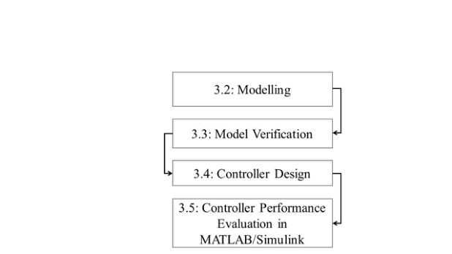

Figure 3.1: Methodology Flow Chart
finite-time convergence.
To further enhance controller performance, Particle Swarm Optimization (PSO)
is employed for systematic gain tuning. This optimization process minimized
tracking error and control effort, improving convergence speed and robustness.
The overall system was evaluated in MATLAB/Simulink under various trajectory
profiles and disturbance scenarios to validate the effectiveness of the proposed
control scheme.
3.2 Modeling and Analysis of Quadrotor Flight
Dynamics
3.2.1 Preliminary Notions of Quadrotor UAV
Quadrotor is a type of UAV which holds electronic board at the middle, and
a pair of propellers on the rotor of Brushless DC (BLDC) motors [49] at four
extremities. There are two possible configurations in Quad design such as “Plus
(+)” configuration in which a single rotor leads the Quad, and “Cross (X)” con-
figuration where two rotors lead the Quad.
30

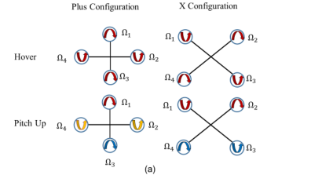
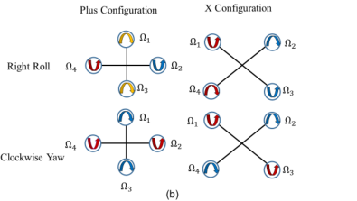

However, the most popular one is X-configuration since it is more stable and
doesn’t have camera obstruction. To command thrust, roll, pitch, and yaw in-
dependently, propellers at the opposite ends of the same arm rotate in the same
direction in the way that pair of propellers on one arm rotate clockwise (CW)
while the other pair rotate in counter clockwise (CCW) direction [50].
Depending on the angular speed of each propeller, it is possible to determine the
direction of Quadrotor maneuvering as shown in Figure 3.2 where the color of
arrow inside the propellers are proportional to the magnitude of angular speed
of the propellers meaning that red,yellow and blue represents High,Medium and
Low speed respectively.
Figure 3.2: Types of quadcopter configurations showing motion generation through
propeller speed variation: (a) hover and pitch motion, (b) roll and yaw motion.
Flight mode of Quadrotor can be controlled to desired pose in the space by
changing the direction and velocity of each propellers[51]. The thrust forces
caused by propellers rotation are responsible for ascending or descending flight.
As shown in Figure 3.2 (b), applying speed difference between side propellers
result in roll rotation coupled with y-axis translation. Similarly the pitch rotation
coupled with translation motion along x-axis is caused due to the speed difference
between front and rear propellers as shown in Figure 3.2 (a). The yaw rotation
is caused due to unbalanced rotation speed of the four propellers. Unlike the roll
and pitch rotation, yaw rotation is the result of reactive torques shown below
which can be found also in Figure.3.3
31

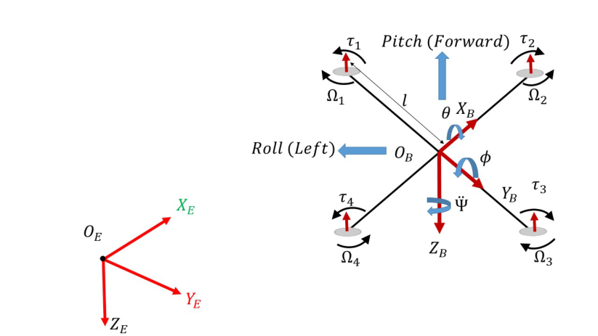

τi, i = 1, 2, 3, 4 represents the individual torque of each rotor,
Ωi, i = 1, 2, 3, 4 represents the angular velocity of each rotor.
Increasing CCW rotated propellers speed result in yaw CW vehicle rotation.
In order to design mathematical model of Quadrotor, the coordinate frame of
Quadrotor has to be defined first. There are two coordinate frames, as shown in
Figure 3.3, that the Quadrotor will operate in: inertial or fixed frame (xi, yi, zi)
and body or mobile frame (xb, yb, zb)[52]. Inertial Frame (IF) is where the Newton
laws are valid and defined with respect to the ground with positive z axis pointing
in the opposite direction of gravity, whereas Body Frame (BF) is defined with
respect to Center of Gravity (CoG) of the Quadrotor with its axes fixed to the
body.
Figure 3.3: Quadrotor free body diagram and its reference frames
The necessity of defining those reference frames is because of: actuator inputs U
and thrusts T, Inertial Measurement Unit (IMU), Accelerometer, Magnetometer
are manipulated and measure quantities with respect to Body Frame (BF). Also
32

GPS measures position with respect to Inertial Frame and Model development is
carried out with respect to IF since Newton laws are valid in IF only.
3.2.2 Mathematical Modeling of Quadrotor Dynamics
Most real world systems are inherently nonlinear. Control engineers address
this challenge through two primary approaches: designing linear controllers by
linearizing the nonlinear system at an operating point, or developing nonlinear
controllers based on simplified models that omit features with negligible effects.
Although simulations typically show excellent performance with tracking errors
converging to zero, implementation on actual systems often reveals divergent error
behavior [53]. This performance gap occurs because controllers are designed using
linearized or simplified models rather than the true plant dynamics.
The unmodeled dynamics, neglected during model development, can substantially
reduce controller effectiveness and may even cause system instability. To miti-
gate the adverse effects of unmodeled dynamics, this section introduces a more
realistic representation of the quadrotor system by incorporating all factors that
significantly influence its dynamic behavior. This approach is motivated by a fun-
damental principle in control engineering, improving the accuracy of the system
model generally enhances controller performance, even though it may increase
the overall complexity of the model [53].
In order to derive mathematical model of Quadrotor dynamics, it is important
to make the following assumptions [54],[55].
1. Structure of the Quadrotor is rigid with constant mass and uniform sym-
metry,
2. Gravitational force doesn’t change with altitude,
33

3. Quadrotor center of mass coincides with its geometric center,
4. The resistance and inductance of Brushless Direct Current ( BLDC) motor
are negligible and
5. At hovering position velocity of air and propellers are equal.
Since the quadrotor structure is assumed to behave as a rigid body, its dynamics
can be derived using Newton’s laws of motion. In the following subsections, the
mathematical model of the quadrotor is developed using the Newton–Quaternion
approach to represent the system dynamics. This formulation is used to describe
the fully actuated rotational dynamics and the underactuated translational dy-
namics based on the free body diagram (FBD) of the quadrotor shown in Fig-
ure 3.3. The quaternion-based representation provides an effective framework for
modeling the quadrotor attitude dynamics and is suitable for real-time imple-
mentation and improved controller performance.
Quadrotor Rotational Motion
By applying Newton’s 2ndlaw of rotational motion to the fully actuated rotational
dynamics of the quadrotor, the resultant moment acting on the system can be
derived from the body frame (BF) as follows:
τi = Jα = [U2, U3, U4]T−Mgyro −Maero (3.1)
where: J = inertia matrix. α = [ ˙p, ˙q, ˙r]Tare angular accelerations in BF; U2, U3,
and U4 are moments on BF which are used to control roll, pitch, and yaw, respec-
tively; Mgyro = gyroscopic moment, and Maero = aerodynamic frictional moment.
34

Inertia Matrix of the Quadrotor The inertia matrix of the quadrotor is
assumed to be constant. Since the quadrotor structure is considered symmetric
with respect to the coordinate axes, the products of inertia satisfy Jxy = Jxz =
Jyz = 0, and the moments of inertia about the x and y axes are equal, i.e.,
Jxx = Jyy [56]. Consequently, the inertia matrix of the quadrotor reduces to a
diagonal form. Here, Jxx, Jyy, and Jzz represent the moments of inertia about
the principal axes of the body frame (BF).
 | Jxx | −Jxy | −Jxz | 

J = | −Jxy  −Jxz | Jyy | −Jyz |  | (3.2)
J = | −Jxy  −Jxz | −Jyz | Jzz |  | (3.2)

Jxx | 0 | 0 | 

J = |  | 0 | Jyy | 0 |  | (3.3)
J = |  | 0 | 0 | Jzz |  | (3.3)
Euler’s Equations of Rigid Body Dynamics Euler’s rotational equations
form a vector quasi-linear first-order ordinary differential equation that describes
the rotational motion of a quadrotor in the Body Frame (BF) with respect to the
Inertial Frame (IF). Let the unit vectors⃗i,⃗j, and⃗k denote the standard basis
vectors of the rotating body frame. If the body frame rotates with an angular
velocity ω relative to the fixed inertial frame, then the time derivative of each
rotating unit vector⃗i,⃗j, and⃗k, represented generically by the unit vector ⃗u, can
be expressed as follows:
d  dt⃗u = ω × ⃗u | (3.4)
Since the angular velocity and angular acceleration of the quadrotor are vector
35

quantities, their magnitudes and directions in the rotating Body Frame (BF) vary
with time relative to the Inertial Frame (IF). Therefore, by applying the chain
rule, the net moment of the quadrotor can be expressed as follows:
Jα = J d dt(ω⃗u) = J dωdt ⃗u+ d dt(Jω⃗u) = J dωdt ⃗u+ω×(Jω⃗u) = J dωdt+ω×(Jω) = J ˙ω+ω×(Jω)
(3.5)
Gyroscopic Effect of Propellers
The spinning propellers induces a gyroscopic torque when the Quad rotates in
the space [57]. This induced torque act on the axis which is perpendicular to
stationary axes of propellers rotation and axes of Quad body rotation along x-
axis or y-axis, and it is expressed as:
Mgyro = JpΩ× ω (3.6)
where ω is speed of Quad body rotates along x or y axis, Ωis angular speed
of propellers, and Jp is inertia of propeller. Since a Quad has four propellers
or rotors, we need to solve the gyro induced torque separately four times along
x-axis and four times along y-axis. Based on Figure 3.3 propeller 2 and 4 rotates
in CCW direction, and 1 and 3 in CW direction, the resultant gyroscopic moment
along x-axis: Mxgyro, and y-axis: Mygyro expressed as follows:
Mxgyro = JpqΩr (3.7)
Mygyro = −JppΩr (3.8)
36

where: Ωr = −Ω1 +Ω2 −Ω3 +Ω4 is the net angular velocity of the propellers and
Ωi (i = 1, 2, 3, 4) is velocity of each propeller. Equation (3.7) implies that induced
torque about x-axis due to angular rate of change to pitch q, i.e. a Quad will feel
a body roll-induced torque when it pitches; this is due to the gyroscopic effect
of the four propellers. The same thing is expressed in Equation (3.8) for y-axis
induced gyroscopic torque. Rotation about z-axis contributes no gyroscopic effect
from the propellers rotation because the axis of propellers rotation and vehicle
rotation axis pointing in the same direction, so the cross product becomes zero,
i.e., no torque is induced during yaw or z-axis rotation.
Aerodynamic Effects due to Propellers Rotation
This is also known as viscous frictional torque in BF resulting from aerodynamic
friction, and it’s given as [58]:
Maero = Caω (3.9)
where Ca is an aerodynamic coefficient depending on air density and the angular
speed of the quadrotor ω.
The aerodynamic coefficient Ca represents the rotational viscous damping coef-
ficient caused by air resistance during quadrotor rotation. In this study, it was
obtained from experimentally reported quadrotor parameters in the literature
[59, 60] and adopted as a constant damping coefficient for the rotational axes.
Since the quadrotor is assumed to be symmetric, the aerodynamic coefficients
about roll, pitch, and yaw were taken as equal, such that
Caϕ = Caθ = Caψ = Ca (3.10)
37

Thus, the aerodynamic moment can be expressed as
 | Caϕp |  | Cap

Maero = | Caθq  Caψr |  | = |  | Caq |  | (3.11)
 |  |  |  |  | Car |  | (3.11)
where p, q, and r are the angular velocities of the quadrotor about the body-frame
x, y, and z axes, respectively. The value of Ca was selected from validated quadro-
tor model parameters and represents the combined effect of air density, propeller
rotation, and rotational aerodynamic damping. This coefficient improves the re-
alism of the mathematical model by accounting for resistive aerodynamic torque,
which is usually neglected in simplified quadrotor models.
By substituting equation (3.5)-(3.9) in Eq.(3.1), rotational dynamics of Quadrotor
is derived as follows:
Jα = [U2, U3, U4]T−Mgyro −Maero
J ˙ω + ω × (Jω) = [U2, U3, U4]T−Mgyro −Maero (3.12)
˙ω = J−1 [U2, U3, U4]T−ω × (Jω) −Mgyro −Maero
˙p | Jxx | 0 | 0 | −1   | U2 |  |  | Jzzqr −Jyyqr |  |  | JpqΩr |  | Cap

 | ˙q |  | = |  | 0 | Jyy | 0 |  | U3  U4 |  | − | Jxxpr −Jzzpr  Jyypq −Jxxpq |  | − | −JppΩr   0 |  | − |  | Caq | 
 | ˙r |  | = |  | 0 | 0 | Jzz |  |  |  |  |  |  |  |  |  |  |  | Car | 
(3.13)
Hence,
38

    ˙p = |  | 1 | U2 +Jyy −Jzz  Jxx | qr −Jp  Jxx | qΩr −Cap  Jxx | p, | (3.14)
 |  | Jxx


     |  | 1 | U3 +Jzz −Jxx  Jyy | pr +Jp  Jyy | pΩr −Caq  Jyy | q, | (3.14)

˙q =
 |  | Jyy

     |  | 1 | U4 +Jxx −Jyy  Jzz | pq −Car  Jzz | r | q, | (3.14)


     | ˙r =
     | ˙r = | Jzz
Quadrotor Translational Motion
Translational dynamics of Quadrotor is derived based on Newton 2ndlaw of transla-
tional motion. Since Newton’s laws are valid only in Inertial Frame (IF), we use the
rotation matrix which project thrust force that generated in Body Frame (BF) into IF.
In these scenario, translational dynamics of Quadrotor is derived in Newton–Quaternion
formalism as follows:
Newton–Quaternion Formalism
By applying Newton–Quaternion approach, Quadrotor translational dynamics is de-
rived as:
a = 1 | Re bU1 −Fg −Fd | (3.15)
m | Re bU1 −Fg −Fd | (3.15)
Substituting Eqn (2.33), gravity and drag forces in Eqn (3.15) it is found to be:
          ¨x = 2(q1q3 −q0q2)U1 m−Cdx   |  |  |  | (3.16)
   | ¨y = 2(q2q3 + q0q1)U1 m−Cdy |  |  | (3.16)
   | ¨z = | 2(q2 0+ q2 3) −1 | m−g −Cdz | (3.16)




Total Thrust Force and Moments Produced by Propellers
The thrust generated by a rotor results from accelerating air downward. According to
Newton’s second law, thrust is equal to the rate of change of momentum of the airflow
39

T =dp  dt | (3.17)
where p is the momentum of the air. Since momentum is the product of mass and
velocity,
p = mΩ (3.18)
the thrust can be written as
T =d dt(mΩ) | (3.19)
The mass of air passing through the rotor disk is expressed as
m = ρV (3.20)
where ρ is the air density and V is the volume of air. For a rotor disk of area A and
airflow displacement S, the volume is V = AS, thus
m = ρAS (3.21)
Substituting into the momentum equation yields
T =d dt(ρASΩ) | (3.22)
Assuming constant air density and rotor area,
T = ρAΩdS  dt | (3.23)
40

At hover, the air velocity through the rotor disk is constant, therefore
dS  dt= Ω | (3.24)
which leads to
T = ρAΩ2 (3.25)
Hence, the induced velocity is
Ω= | T | (3.26)
Ω= | ρA | (3.26)
The power required during hovering is the product of thrust and induced velocity
P = TΩ (3.27)
Substituting the induced velocity gives
3
P=T | 2 | (3.28)
√ρA |  | (3.28)
where ρ is the air density, A is the rotor disk area, S is the airflow displacement, and Ω
is the induced air velocity at hover. Using equation (3.28), the power required by the
BLDC motor to generate the corresponding thrust can be determined.
Actuators Dynamics
The actuator dynamics of the propeller motor assembly can be derived from the elec-
trical and electromechanical relationships of the trapezoidal BLDC motor. Since the
voltage equation of a trapezoidal BLDC motor is similar to that of a conventional
DC motor, Kirchhoff’s Voltage Law (KVL) applied to the per phase equivalent circuit
41

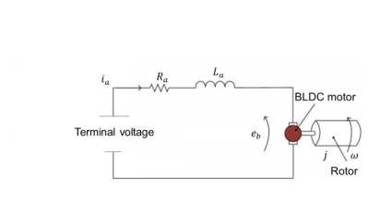

Figure 3.4: Per phase equivalent circuit of a trapezoidal BLDC motor
shown in Figure 3.4 gives
Va = Raia + La | dia | (3.29)
Va = Raia + La | dt+ eb | (3.29)
where Va is the applied terminal voltage (V), Ra is the stator phase resistance (Ω),
La is the stator phase inductance (H), ia is the stator current (A), and eb is the back
electromotive force (V).
The back electromotive force is proportional to the rotor angular velocity and is ex-
pressed as
eb = KvΩ (3.30)
where Kv is the back electromotive force (EMF) constant (V s/rad) and Ωis the rotor
angular velocity (rad/s).
Under steady state operation and for a simplified actuator model, the voltage drops
across the stator resistance and inductance are assumed negligible compared to the
back-EMF. Therefore, the voltage equation reduces to
Va ≈eb = KvΩ (3.31)
The electromagnetic torque produced by the motor is proportional to the stator current,
that is,
τm = Kτia (3.32)
where τm is the motor electromagnetic torque (N m) and Kτ is the motor torque con-
42

stant (N m/A). Rearranging gives
ia =τm  Kτ | (3.33)
The electrical power consumed by the motor during hovering is given by
P = Vaia (3.34)
where P is the electrical input power (W). Substituting Va = KvΩand ia = τm/Kτ
yields
P = KvΩτm  Kτ | (3.35)
For the propeller motor system, the motor torque is assumed proportional to the gen-
erated thrust. Thus,
τm = KtT (3.36)
where Kt is the torque thrust proportionality constant and T is the thrust generated
by the propeller (N). Substituting this relation into the power expression gives
P=Kv | KtTΩ | (3.37)
Kτ | KtTΩ | (3.37)
On the other hand, from momentum theory, the aerodynamic power required to gen-
erate thrust can be expressed as
P =T 3/2  √ρA | (3.38)
where ρ is the air density (kg/m3) and A is the rotor disc area (m2).
Combining (3.38) and (3.37) gives
√ρA =Kv | KtTΩ | (3.39)
43

Dividing both sides by T results in
T1/2=Kv | Kt | ρA Ω | (3.40)
Kτ | Kt | ρA Ω | (3.40)
Squaring both sides gives
T = | Kv | Kt | ρA | 2 | Ω2 | (3.41)
T = | Kτ
Let
b = | Kv | Kt | ρA | 2 | (3.42)
b = | Kτ

where b denotes the lumped thrust coefficient. Hence, the thrust generated by the
propeller is obtained as
T = bΩ2 (3.43)
Equation (3.43) shows that the thrust produced by each propeller is proportional to the
square of its angular speed. Using equations (3.28) and (3.43), the relationship among
propeller speed, thrust, and power can be determined. Consequently, the required
power delivered by the Electronic Speed Controller (ESC) to the BLDC motor can
be estimated in order to achieve the desired propeller speed and generate the thrust
necessary to drive the quadrotor according to the commanded input.
Total Thrust Force and Moments Derivation
Based on free body diagram of Quadrotor in Figure 3.3 and equation (3.43), total
thrust force U1 due to rotation of each propeller is solved as follows: Since all the
thrust forces are acting in upward direction:
U1 = T1 + T2 + T3 + T4 = bΩ2 1+ bΩ2 2+ bΩ2 3+ bΩ2 4= b(Ω2 1+ Ω2 2+ Ω2 3+ Ω2 4) | (3.44)
The rolling control torque U2 in positive ϕ direction is solved as follows:
44

U2 = ℓ(T1 −T2 −T3 + T4) = ℓ(bΩ2 1−bΩ2 2−bΩ2 3+ bΩ2 4) = ℓb(Ω2 1−Ω2 2−Ω2 3+ Ω2 4) (3.45)
where ℓis distance between rotor center and CoG of Quadrotor, and the positive and
negative sign indicate the rotor at which their speed increase and decrease, respectively,
in the way that maintaining the overall thrust U1 constant.
The pitching control torque U3 in positive θ direction is solved as follows:
U3 = ℓ(T1 + T2 −T3 −T4) = ℓ(bΩ2 1+ bΩ2 2−bΩ2 3−bΩ2 4) = ℓb(Ω2 1+ Ω2 2−Ω2 3−Ω2 4) (3.46)
The yaw control torque U4 is solved based on the concept of Newton third law of
motion, which states that for any action torque there is reactive torque generated by
drag torque τi(i = 1, 2, 3, 4). Due to this drag torque, yaw rotation is caused in the
direction of net drag torque. For instance, if (τ2+τ4) > (τ1+τ3), the Quad will rotate in
positive yaw direction. In the same way as equation (3.43), drag torque mathematically
formulated as τ = dΩ2, where d is aerodynamic drag coefficient. Hence, yaw control
torque becomes:
U4 = d(−Ω2 1+ Ω2 2−Ω2 3+ Ω2 4) | (3.47)
45

By combining equations (3.44)-(3.47), control mixing matrix is derived as follows:
U1 |  |  | b | b | b | b |  | Ω2  1 | 

U2  U3  U4 |  | = | bℓ  −d  bℓ | −bℓ | −bℓ | bℓ  −bℓ  d  | Ω2  2  Ω2  Ω2  3  4 |  | (3.48)
 |  |  |  | bℓ | −bℓ
 |  |  |  | d | −d
By using Symbolic Math ToolboxTM4in MATLAB®, then, Control allocation
or mixing equations become:
    Ω1 =                    Ω2 = | 4b+ U2 4bℓ+ U3 4bℓ−U4  4b−U2 4bℓ+ U3 4bℓ+ U4
(3.49)
      Ω3 =                  Ω4 = | 4b−U2 4bℓ−U3 4bℓ−U4  4b+ U2 4bℓ−U3 4bℓ+ U4
By combining Newton-Quaternion approach which described in equations (3.1) - (3.49)
we have
       | ¨x = 2(q1q3 −q0q2)U1 m−Cdx |  |  | Cap  Jxxp | (3.50)
             | ¨y = 2(q2q3 + q0q1)U1 m−Cdy |  |  | Cap  Jxxp | (3.50)
   |  |  |  | Cap  Jxxp | (3.50)
   | ¨z = | 2(q2 0+ q2 3) −1 | m−g −Cdz | Cap  Jxxp | (3.50)


   |  |  |  | Cap  Jxxp | (3.50)
   | ˙p = | JxxU2 + Jyy−Jzz | qr −Jp JxxqΩr − | Cap  Jxxp | (3.50)




 |  |  |  | Caq  Jyyq | (3.50)
   | ˙q = | JyyU3 + Jzz−Jxx | pr +Jp JyypΩr − | Caq  Jyyq | (3.50)

 | ˙r = | JzzU4 + Jxx−Jyy | pq −Car Jzzr | Caq  Jyyq | (3.50)


   |  |  |  | Caq  Jyyq | (3.50)
          ˙q0 =1 2(pq1 + qq2 + rq3) |  |  |  | Caq  Jyyq | (3.50)
   |  |  |  | Caq  Jyyq | (3.50)
          ˙q1 =1 2(pq0 + rq2 −qq3) |  |  |  | Caq  Jyyq | (3.50)
   |  |  |  | Caq  Jyyq | (3.50)
      ˙q2 =1 2(qq0 + pq3 −rq1)   |  |  |  | Caq  Jyyq | (3.50)
   |  |  |  | Caq  Jyyq | (3.50)
    ˙q3 =1 2(rq0 + qq1 −pq2) |  |  |  | Caq  Jyyq | (3.50)
From the quadrotor governing dynamics in equation (3.50), the system can be inter-
46

preted as a cascade structure. The translational dynamics depend on the attitude
states of the rotational dynamics, whereas the rotational dynamics are independent of
the translational states. This property will later be exploited in controller design.
The control mixing (or control allocation) equations take the control inputs and
transform them into the corresponding rotor angular speeds. The overall residual (net)
propeller angular speed is given by
Ωr = −Ω1 + Ω2 −Ω3 + Ω4 (3.51)
The quaternion-based quadrotor dynamics in equation (3.50) involve simple quaternion
operations, which reduce computational cost and improve numerical stability. In addi-
tion, quaternion representation enables the design of singularity-free controllers capable
of operating at all attitudes, thereby allowing agile flight and aerobatic maneuvers [61].
However, quaternions are less intuitive for visualization and interpretation.
To address this limitation, quaternion states are often converted into Euler angles,
which are easier to interpret. Using the canonical Euler set, roll and yaw lie within
[−π, π] while pitch lies within | −π  2, π | . The relationship between quaternion and Euler
angles is expressed as [62]
 | ϕ |  | = | arctan 2 | 2(q0q1 + q2q3), q2 0−q2 1−q2 2+ q2 |  |  | (3.52)
θ  ψ |  |  | = | arctan 2 | arcsin | 2(q0q2 −q3q1) |  | (3.52)
 |  |  |  |  | 2(q0q3 + q1q2), q2 0+ q2 1−q2 2−q2 |  |  | (3.52)
Thus, the quaternion formulation in equation (3.50) avoids the singularity problem
encountered in Euler representation (e.g., when the pitch angle approachesπ2rad), while
the conversion in equation (3.52) allows convenient visualization and interpretation of
the quadrotor orientation.
47

3.3 Verification of Mathematical Model
The derived quadrotor dynamic model as shown in equation 3.50 was subjected to
quantitative validation to ensure its physical consistency and suitability for control
design. This verification stage involved a systematic comparison between the developed
model and the established nonlinear quadrotor dynamics expressed in equation 3.53 and
3.54. The comparison was carried out to confirm that the translational and rotational
behaviors, as well as the quaternion-based kinematics, were accurately captured.
To further assess feasibility, the model was implemented in MATLAB®Simulink using
the parameters listed in Table 3.1. Simulation results demonstrated that the model
preserves the inherent coupling between translational and rotational dynamics and
exhibits realistic system responses under typical operating conditions. This agreement
with the standard formulation confirms that the derived model is both mathematically
sound and practically reliable, providing a solid foundation for subsequent controller
development and performance evaluation.
Table 3.1: Specifications for the quadrotor model verification [59, 60]
Symbol | Description | Unit | Value
g | Acceleration due to gravity | ms−2 | 9.81
m | Mass of Quadrotor | Kg | 0.468
Jxx | Body moment of inertia around the X-axis | Nms2 | 4.856 × 10−3
Jyy | Body moment of inertia around the Y-axis | Nms2 | 4.856 × 10−3
Jzz | Body moment of inertia around the Z-axis | Nms2 | 8.801 × 10−3
ℓ | Length of Quadrotor arm | m | 0.225
b | Thrust coefficient | N/m/s | 2.98 × 10−6
d | Drag factor | Nms2 | 1.140 × 10−7
Jp | Rotor or propeller inertia | Nms2 | 3.357 × 10−5
Cap = Caq = Car | Rotationaldragcoefcients | N/m/s | 0.25
Cax = Cav = Caz | Translationaldragcoefcients | N/m/s | 0.2
R | Rotor or propeller Radius | m | 0.25
γ | Correction factor | unit | 0.083
Equations 3.53 and 3.54 were adopted from existing quadrotor modeling studies [9, 53]
and used as baseline models for comparative verification of the proposed quaternion-
48

based model. Their inclusion provides a reference framework for evaluating the effect
of incorporating aerodynamic drag, rotational damping, and quaternion-based atti-
tude representation in the proposed model. By simulating all models under identical
operating conditions, the study was able to assess differences in trajectory response,
stability characteristics, and physical realism, thereby validating the effectiveness and
applicability of the developed mathematical model.
 | ¨x = 2 (q1q3 −q0q2) U1  m |  |  |  |  | +Mgyro | q | (3.53)



   | ¨y = 2 (q2q3 + q0q1) U1 |  |  |  |  | +Mgyro | q | (3.53)






   | m |  |  |  |  | +Mgyro | q | (3.53)
   | ¨z= | 2 | q2 0+ q2 | −1 | U1 | +Mgyro | q | (3.53)





     | m |  |  |  |  | +Mgyro | q | (3.53)
   | ˙p =U2  Jxx |  | −qr (Jzz −Jyy)  Jxx |  |  | +Mgyro | q | (3.53)






   |  |  |  |  |  | Jxx | q | (3.53)
     | ˙q =U3  Jyy |  | −pr (Jxx −Jzz) Jyy |  |  | +Mgyro | p | (3.53)




 |  |  |  |  |  | Jxx | p | (3.53)



˙r =U4 −pq (Jyy −Jxx)


 Jzz Jzz









˙q0 = 1 2 (pq1 + qq2 + rq3)










˙q1 = 1 2 (pq0 + rq2 −qq3)









˙q2 = 1 2 (qq0 + pq3 −rq1)






˙q3 = 1 2 (rq0 + qq1 −pq2)
49

       | ¨x = 2(q1q3 −q0q2)U1 mfGE −Cdx |  |  |  | Cap  Jxxp | (3.54)
             | ¨y = 2(q2q3 + q0q1)U1 mfGE −Cdy |  |  |  | Cap  Jxxp | (3.54)
   |  |  |  |  | Cap  Jxxp | (3.54)
   | ¨z = | 2(q2 0+ q2 3) −1 | mfGE −g −Cdz |  | Cap  Jxxp | (3.54)


   |  |  |  |  | Cap  Jxxp | (3.54)
   | ˙p = | JxxU2fGE + Jyy−Jzz |  | qr −Jp JxxqΩr − | Cap  Jxxp | (3.54)



   |  |  |  |  | Caq  Jyyq | (3.54)
   | ˙q = | JyyU3fGE + Jzz−Jxx |  | pr +Jp JyypΩr − | Caq  Jyyq | (3.54)

 | ˙r = | JzzU4fGE + Jxx−Jyy |  | pq −Car Jzzr | Caq  Jyyq | (3.54)


   |  |  |  |  | Caq  Jyyq | (3.54)
          ˙q0 =1 2(pq1 + qq2 + rq3) |  |  |  |  | Caq  Jyyq | (3.54)
   |  |  |  |  | Caq  Jyyq | (3.54)
          ˙q1 =1 2(pq0 + rq2 −qq3) |  |  |  |  | Caq  Jyyq | (3.54)
   |  |  |  |  | Caq  Jyyq | (3.54)
          ˙q2 =1 2(qq0 + pq3 −rq1) |  |  |  |  | Caq  Jyyq | (3.54)
   |  |  |  |  | Caq  Jyyq | (3.54)
    ˙q3 =1 2(rq0 + qq1 −pq2) |  |  |  |  | Caq  Jyyq | (3.54)
Where fGE is a ground effect factor.
3.4 Design of Controller for Quadcopter
Despite the presence of four rotors, the translational dynamics of a quadcopter remain
underactuated. This means that the system does not possess a sufficient number of
independent control inputs to directly regulate all degrees of freedom (DOF), especially
the lateral motions. To overcome this limitation, virtual control inputs are introduced
so that each output of the quadrotor can follow a predefined reference trajectory [63].
The virtual control inputs can be obtained as follows:



Ux = 2(q1q3 −q0q2) U1 −Cdx ˙x,





Uy = 2(q2q3 + q0q1) U1 −Cdy ˙y, (3.55)

 | 2(q2 0+ q2 3) −1 | U1 −mg −Cdz ˙z.
   | 2(q2 0+ q2 3) −1 | U1 −mg −Cdz ˙z.
   | 2(q2 0+ q2 3) −1 | U1 −mg −Cdz ˙z.
    Uz =   | 2(q2 0+ q2 3) −1 | U1 −mg −Cdz ˙z.
Here, the parameters Ux, Uy, and Uz represent the virtual control inputs responsible
for directing the quadrotor’s position along the x-, y-, and z-axes, respectively. Ac-
cordingly, the translational dynamics of the quadrotor can be expressed as shown in
50

(3.56).
¨x =Ux  m , | ¨y =Uy  m , | ¨z =Uz  m . | (3.56)
To design controller for a second order system, the rotational dynamics of a quadrotor
are rewritten in quaternion using the small quaternion approach.
˙q0 |  | 1 | 0 | 0 | 0 |  | 0 | 0 | 

˙q1  ˙q2  ˙q3 |  | =1 | 0  0  0 | 1 | 0 | 0  0  1 | p  q  r | =1 | p  q  r | (3.57)
˙q1  ˙q2  ˙q3 |  | 2 | 0  0  0 | 0 | 1 | 0  0  1 | p  q  r | 2 | p  q  r | (3.57)
 |  |  |  | 0 | 0
Hence, making angular velocity the subject and differentiating with respect to time:
p | ˙q1 |  | ˙p | ¨q1 | 

 | q |  | = 2 | ˙q2  ˙q3 |  | , |  | ˙q |  | = 2 | ¨q2  ¨q3 |  | (3.58)
 | r |  |  |  |  |  |  | ˙r
Finally, the second-order rotational dynamics of the quadrotor can be expressed using
quaternions as follows:
  ¨q1 =     | 1 | U2 +Jyy −Jzz  Jxx | qr −Jp  Jxx | qΩr −Cap  Jxx | p, | (3.59)
  ¨q1 =     | Jxx
   | 1 | U3 +Jzz −Jxx  Jyy | pr +Jp  Jyy | pΩr −Caq  Jyy | q, | (3.59)



¨q2 =
¨q2 = | Jyy

     | 1 | U4 +Jxx −Jyy  Jzz | pq −Car  Jzz | r. | q, | (3.59)




¨q3 =

  ¨q3 =   | Jzz
The state vector is composed of two components: orientation control, expressed as
[q1, ˙q1, q2, ˙q2, q3, ˙q3] and position control, expressed as [x, ˙x, y, ˙y, z, ˙z].
51

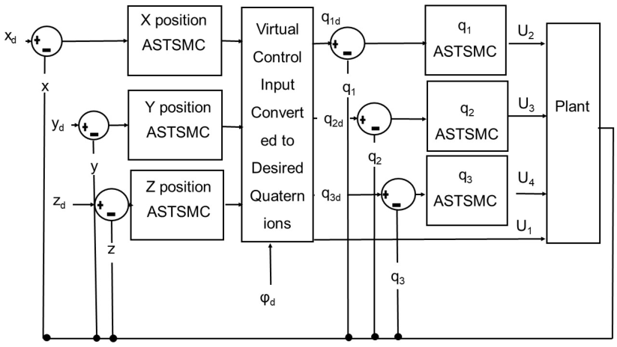

3.4.1 Design of a quadrotor position controller
Figure 3.5: Controller architecture for quadrotor, including position, altitude, and
virtual control input designs
Figure 3.5 shows the general architecture for both position and attitude controller, in
this figure desired xd, yd and zd are compared with actual x, y and z then the errors are
fed to sliding surface and then a position control law are implemented and results to
virtual control inputs which are then combined with desired yaw angle and converted
to desired quaternions which then be used as reference to actual quaternion ready for
manipulating and obtain roll, pitch and yaw control inputs. It is proposed that firstly
a position controller be designed using following steps.
1. Determine the quadcopter desired postion and velocity errors.
ex |  | xd −x | ˙ex |  | ˙xd −˙x

 | ey |  | = |  | yd −y |  | , |  | ˙ey |  | = |  | ˙yd −˙y |  | (3.60)
 | ez |  | = |  | zd −z |  | , |  | ˙ez |  | = |  | ˙zd −˙z |  | (3.60)
52

2. Design sliding surfaces



σx = λxex + cx ˙ex,



σy = λyey + cy ˙ey, (3.61)





σz = λzez + cz ˙ez

Where λi and ci denotes positive position error and velocity error respectively.
3. Design control law and tune the gain of sliding surface using PSO.
Design Super Twisting Sliding Mode Controller (STSMC)
STSMC is given by the equation below:
Ust = −a | |σ| sign(σ) −ν | (3.62)

˙ν =β2 sign(σ) | (3.63)
where σ represents the sliding surface that defines the tracking error dynamics,
while β is a positive adaptive gain parameter that determines the convergence
speed and robustness of the super twisting control law against disturbances and
uncertainties.
The total control law (U) calculated by summing the equivalent and supertwisting
control law:
U = Uequ + Ust (3.64)
where Uequ is equivalent controller and Ust is super twisting controller.
53

Fig. 3.6 illustrates the position controller diagram designed for the quadcopter.
The controller focuses on maintaining the desired trajectory by regulating the
quadcopter position along the x, y, and z axes through the Adaptive Super
Twisting Sliding Mode Controller (ASTSMC). The controller generates the re-
quired control actions to minimize trajectory tracking errors and ensure stable
position tracking under nonlinear dynamics and external disturbances.
In the proposed framework, Particle Swarm Optimization (PSO) is incorporated
as an offline optimization technique for systematic tuning of the ASTSMC con-
troller parameters. The PSO algorithm operates by iteratively updating a pop-
ulation of candidate solutions, referred to as particles, in order to minimize a
predefined objective function based on trajectory tracking performance indices
such as the Integral Time Absolute Error (ITAE). During the optimization stage,
each particle represents a candidate set of controller gains, and the fitness of each
particle is evaluated through MATLAB/Simulink simulations of the quadcopter
system.
Once the optimal controller parameters are obtained, the PSO process is termi-
nated and the optimized gains are fixed for controller implementation. Therefore,
PSO does not participate in the real-time control loop during quadcopter oper-
ation. Instead, the real-time control action is performed solely by the ASTSMC
controller using the pre-optimized parameters obtained from the offline PSO tun-
ing process. The PSO block is included in the control architecture to illustrate
the optimization mechanism used for selecting the controller gains systematically.
After selecting the sliding surface, the next step is to design the equivalent control
law, and this law ensures the system remains in sliding mode during operation.
Equivalent control law can be designed by making ˙σx, ˙σy, ˙σz = 0.
The virtual controller (Ux, Uy, Uz) which means that the three common inputs
will control motion along x, y and z and these virtual controls are given by
54

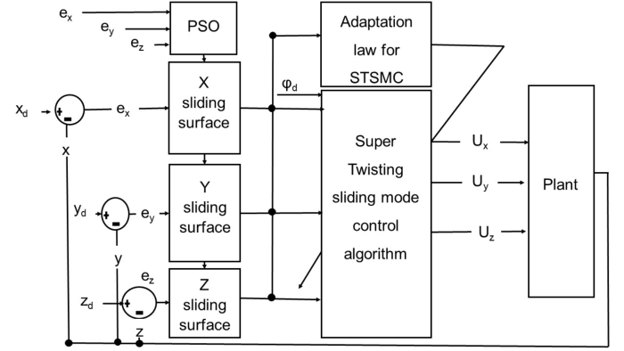

equation.
    Ux =λx |  | ˙ex + ¨xd −ax | |σx| sign(σx) −vx, | (3.65)
   | cx | ˙ey + ¨yd −ay | |σy| sign(σy) −vy, | (3.65)
   |  | ˙ey + ¨yd −ay | |σy| sign(σy) −vy, | (3.65)
 | Uy =λy | ˙ey + ¨yd −ay | |σy| sign(σy) −vy, | (3.65)
     | cy | ˙ey + ¨yd −ay | |σy| sign(σy) −vy, | (3.65)
 |  | ˙ez + ¨zd −az | |σz| sign(σz) −vz. | (3.65)
         | Uz =λz  cz | ˙ez + ¨zd −az | |σz| sign(σz) −vz. | (3.65)
where a and β are the gain of super twisting algorithm and ˙v = −β2sign(σ).
Figure 3.6: Diagram of position controller for maintaining quadrotor trajectory along
x,y,and zaxes
Theorem 1 If the quadrotor position system (3.50), is taken into consideration,
together with the PSO based sliding manifold (3.62), control laws (3.65), and
tracking errors (3.60), asymptotically, the closed loop tracking error can approach
zero.
The control law must ensure that˙V (z) < 0 and the system state variables V (z) >
0.
Proof. Lyapunov function is a positive scalar function, defined as
Vz =1 2σT zσz= 1 2σ2 | (3.66)
Now differentiating Vz with respect to time it is found to be:
55

˙Vz = σz ˙σz < 0 = σz | λz ˙ez + cz(¨zd −¨z) | (3.67)
To substitute the value of ¨z, use the virtual control law.
= λz ˙ez + cz | ¨zd −az | |σz| sign(σz) − | βz sign(σz) dt | (3.68)

˙Vz = σz | λz ˙ez + cz¨zd −λz ˙ez −cz¨zd −az | |σz| sign(σz) − | βz sign(σz) dt
(3.69)
˙Vz = σz | −az | |σz| sign(σz) − | βz sign(σz) dt | ≤0 | (3.70)
To make the Lyapunov function valid, the gains az, βz should be above positive.
The virtual control in Eq. 3.65, used to determine desired quaternion value.
When x, y, and z approach xd, yd, and zd as time reaches the sliding surface
σx = 0, σy = 0, σz = 0 and the designed controller derives the actual value
to the desired position. The desired quaternion value can also be calculated by
rearranging the virtual control inputs.
 | U1 = | U2x + U2y + (Uz + mg)2, |  |  |  |  |  | −2 sin2 | ψd | + 1, | (3.71)






   |  | Uz + mg |  |  | −2 sin2 | ψd | + 1,




q0d =1
 |  | U1 |  |  | −2 sin2 | 2




   |  |  | ψd | Ux + | 1  √2Uy | Uz + mg


q1d = sin
 |  |  | 2 | Ux + | 1  √2Uy | U1 |  | −2 sin2 | 2 | + 1, | (3.71)

 |  | ψd | Uy − | 1  √2Ux | Uz+mg | −2 sin2 | ψd | + 1 | ,


           | sin
           | sin | 2 | Uy − | 1  √2Ux | U1 | −2 sin2 | 2 | + 1 | ,
    q2d =   |  | ψd | . | Uz + mg + U1 |  |  | 2 | + 1 | ,









q3d = sin
 |  | 2
56

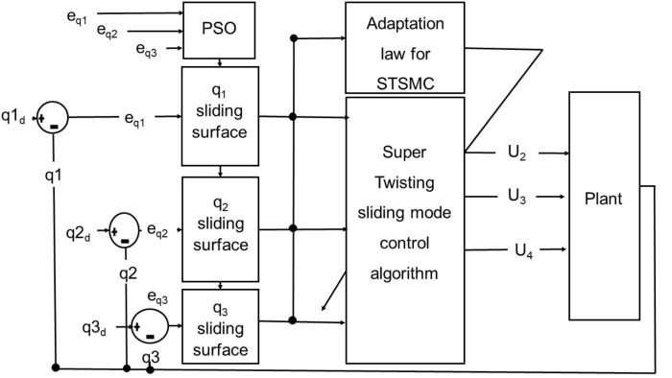

3.4.2 Attitude controller design
Fig 3.7, depicts the attitude controller diagram responsible for maintaining the
quadcopter desired altitude. The controller operates by generating control input
signals based on the reference inputs provided by the conversion blocks. By
generating the input control signal (U2, U3, U4), the Adaptive Super Twisting
Sliding Mode Control maintains the tracking errors of the attitude subsystem.
Figure 3.7: Attitude controller diagram for maintaining desired quadrotor altitude
The tracking errors are defined:
eq1 |  | q1d −q1 | 

eq3  eq2 |  | = | q3d −q3 q2d −q2 |  | (3.72)
Like position control design, to design attitude controller first step is designing
of sliding surface:



σq1 = λq1eq1 + cq1 ˙eq1




σq2 = λq2eq2 + cq2 ˙eq2 (3.73)







σq3 = λq3eq3 + cq3 ˙eq3
57

Theorem 2. If the quadrotor attitude system , is designed with PSO-based
sliding (3.50) surfaces (3.73), the closed loop system’s tracking errors (3.72), can
asymptotically converge to zero.
Proof. The Lyapunov function is stated as Vq1 =1 2σT q1σq1, with V (q1) > 0 and
the control law requiring ˙V (q1) < 0.




Vq1 =1 2σT q1σq1








˙Vq1 = σq1 ˙σq1 ≤0









˙Vq1 = σq1 λq1eq1 + cq1(¨q1d −¨q1)



˙Vq1 = σq1     |  | λq1eq1 + cq1 ˙q1d −cq1 |  |  | Jyy −Jzz |  | ˙q1 ˙q3 −Jt  Jxx |  | ˙q1ω | (3.74)
 |  |  |  |  | Jxx |  |  |  | ˙q1ω | (3.74)
   |  | λq1eq1 + ˙q1d − |  | Jyy −Jzz |  | ˙q1 ˙q3 −Jt  Jxx |  | ˙q1ω | + Ust | (3.74)






     | U2= Jxx
 |  |  |  | Jxx |  |  |  | ˙q1ω | ≤0 | (3.74)
  




   |  | −aq1 | |σq1| sign(σq1) − |  |  | βq1sign(σq1)dt |  |  | ≤0 | (3.74)



˙Vq1 = σq1
Consequently, the attitude tracking errors will asymptotically approach zero, and
the attitude control inputs becomes
    U2 =Jxx |  |  | −2aq1 |  | |σq1| sign(σq1) + νq1 −λq1p | (3.75)
     | cq1 |  |  |  | |σq1| sign(σq1) + νq1 −λq1p | (3.75)
     |  |  |  |  |  | (3.75)
       | −(Jyy −Jzz)qr + JpqΩr + Capp |  |  |  |  | (3.75)
       |  |  |  |  |  | (3.75)
        U3 =Jyy |  | −2aq2 |  | |σq2|sign(σq2)+ νq2 −λq2q |  | (3.75)
cq2 |  |  |  |  |  | (3.75)



 −(Jzz −Jxx)pr −JppΩr + Caqq










U4 =Jzz −2aq3 |σq3| sign(σq3) + νq3 −λq3r

 cq3





 −(Jxx −Jyy)pq + Carr
˙ν = −β2sign(σ)
58

3.4.3 SMC gain tuning
In this research, Particle Swarm Optimization (PSO) was chosen to automati-
cally tune the altitude and attitude control gains of the Sliding Mode Controller
(SMC) for the quadcopter system. Although other optimization techniques such
as Genetic Algorithm (GA), Ant Colony Optimization (ACO), and Differential
Evolution (DE) are also widely used in controller parameter tuning, PSO was
preferred because of its simple mathematical structure, fewer tuning parameters,
fast convergence speed, and low computational burden [64]. These characteristics
make PSO more suitable for nonlinear and highly coupled quadcopter dynamics,
where rapid and stable optimization of controller gains is required.
Furthermore, compared to conventional manual tuning methods and other evolu-
tionary algorithms, PSO demonstrated better capability in minimizing tracking
errors and reducing chattering effects while maintaining robust trajectory track-
ing performance. The particle swarm approach was developed by the movements
of birds and swimming fish, the notion for the optimization of nonlinear systems
was further developed in [65].
The various parameters that make up this fitness function are taken from tra-
jectory monitoring and regulation of the coupled and nonlinear dynamics of a
quadcopter. Every particle’s position is associated with SMC. Each particle’s
speed in the two simulations is corresponding to this parametrized change. Ev-
ery particle and variable has its position and velocity initialized at random. Every
particle travelled across the search space, and every particle’s effectiveness was
assessed on a regular basis.
The PSO algorithm was computationally efficient, conceptually straightforward,
and simple to apply. Fig. 3.8 presents the flowchart of PSO algorithm, which was
employed to fine-tune the control parameters of the quadcopter sliding surface.
The PSO algorithm iteratively optimized the sliding surface gains. The flowchart
outlines the key steps of the PSO process, from initializing the particles’ positions
59

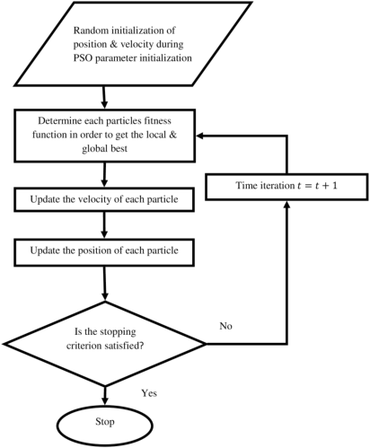

and velocities to evaluating their performance and updating their positions based
on the best-performing particles.
Figure 3.8: PSO algorithm flowchart used for tuning quadrotor sliding surface param-
eters [9].
3.4.4 Fitness function
Using the proposed approach, a performance index was used to quantify the
optimization performance of the quadrotor’s responses. The purpose of the per-
formance index, sometimes referred to as the fitness function, was to reduce the
differences between the quadrotor’s controllable and desired output responses.
The objective of this study was to minimize the quadrotor trajectory tracking
error in terms of both position and orientation. Systems designed using the
Integral Time Absolute Error (ITAE) criterion exhibited minor overshoots and
minimal damped oscillations [9].
In this study, the Integral Time Absolute Error (ITAE) criterion was selected as
the performance index for tuning and evaluating the controller because it places
greater penalty on errors that persist over time. Unlike the Integral of Absolute
60

Error (IAE), which treats all errors equally, and the Integral of Squared Error
(ISE), which heavily penalizes large transient errors, ITAE emphasizes rapid error
elimination and improved steady-state performance.
Similarly, although the Integral of Time Squared Error (ITSE) also considers
time weighting, it tends to produce aggressive control actions due to the squared
error term. Since quadrotor trajectory tracking requires smooth response, re-
duced oscillations, faster settling time, and minimal steady-state error under
disturbances, ITAE was considered more suitable for achieving balanced overall
control performance in this research.
∞
ITAE = | t|e(t)| dt | (3.76)
0
The fittness function used in tunning gains for position controller was as follows:
∞
ITAE = | t (|e(x)| + |e(y)| + |e(z)|) dt | (3.77)
0
The fittness function used in tunning gains for attitude controller is as follows:
∞
ITAE = | t (|e(q1)| + |e(q2)| + |e(q3)|) dt | (3.78)
0
Below are the PSO’s parameters that were used during tuning for attitude and
position controller gains as shown in Table 4.1 and Table 4.2. The selected PSO
parameters were chosen to provide a balanced search between exploration and
convergence during controller gain tuning.
The upper bounds uba = 100 and ubp = 100 were selected to give the particles
a sufficiently wide search space for both attitude and position gains, while the
lower bounds were set to zero because the sliding surface and controller gains
must remain positive to satisfy stability requirements.
The velocity limits vmax = 1 and vmin = 0.1 were used to regulate the particle
61

movement and prevent abrupt jumps that could lead to unstable or unrealistic
controller gains. The acceleration coefficients c1 = 2 and c2 = 2 were selected to
give equal importance to the particle’s individual best experience and the global
best solution of the swarm.
This choice provides a good compromise between local exploitation and global
exploration, which is suitable for tuning nonlinear quadrotor controller gains.
Therefore, the selected PSO parameters ensured stable convergence, avoided ex-
cessive control effort, and produced feasible controller gains for the proposed
ASTSMC.
uba = 100 100 100 100 100 100 100 100 100 100 100 100
lba = 0 0 0 0 0 0 0 0 0 0 0 0
ubp = 100 100
lbp = 0 0
vmax = 1, | vmin = 0.1, | c1 = 2, | c2 = 2
62

uba = upper attitude bound,
lba = lower attitude bound,
ubp = upper position bound,
lbp = lower position bound,
Note:
vmax = maximum particle swarm velocity coefficient,
vmin = minimum particle swarm velocity coefficient,
c1 = first particle swarm acceleration coefficient,
c2 = second particle swarm acceleration coefficient.
3.4.5 Adaptive Super Twisting Sliding Mode Control
design
Control structure of Adaptive Super Twisting Sliding Mode Control.
Subsequently, the Super Twisting Sliding Mode Control approach was incorpo-
rated to enhance robustness and reduce the chattering effect associated with
conventional Sliding Mode Control.
1
Ust = −a|σ| 2 sign(σ) + ν
˙ν = −β2sign(σ)
The adaptive gains were stated as follows:
a = a(σ, ˙σ, t) (3.79)
β = β(σ, ˙σ, t) (3.80)
Lemma 1. The adaptation law was defined as:
63

˙a = |  | √γ1  √2sign(|σ| −µ), | if a > am | (3.81)
˙a = |     ω1 | √γ1  √2sign(|σ| −µ), | if a > am | (3.81)

      η,   | if a ≤am
β = 2ϵa
The parameters ϵ, γ1, ω, η are arbitrary positive constants, while am is a small
positive constant.
Proof. Lyapunov function candidate is introduced as:
ν(a, β) = ν0 + | 2γ1(a −a∗)2 + | 2γ2(β −β∗)2 | (3.82)
where ν0 is Lyapunov function for (σ, ˙σ), a∗, β∗were maximum possible values
of a, β respectively. The derivative of the Lyapunov function is as follows:
˙ν(σ, a, β) ≤−η0 | ν(σ, a, β) −|ϵa| | γ1˙a − | ω1
˙ν(σ, a, β) ≤−η0 | ν(σ, a, β) −|ϵa| | γ1˙a − | √2γ1

−|ϵβ| | γ2˙β − | ω2 | (3.83)
−|ϵβ| | γ2˙β − | √2γ2 | (3.83)
It gives
˙ν(σ, a, β) ≤−η0 | ν(σ, a, β) + ζ | (3.84)
with
ζ = −|ϵa| | γ1˙a − | ω1 | −|ϵβ| | γ2˙β − | ω2 | (3.85)
ζ = −|ϵa| | γ1˙a − | √2γ1 | −|ϵβ| | γ2˙β − | √2γ2 | (3.85)
where ϵa = a −a∗and ϵβ = β −β∗. It is evident that the system’s finite-time
64

Table 3.2: Plant parameter [67].
Plant Parameters | Symbol | Unit | Values
Thrust coefficient | b | Ns2 | 54.2 × 10−6
Drag factor | d | Nms2 | 1.1 × 10−6
Gravitational Acceleration | g | m/s2 | 9.81
The length of the arm of the quadrotor | l | m | 0.24
Mass of quadrotor | m | Kg | 1
Inertia around X-axis | Jxx | Nms2 | 8.100 × 10−3
Inertia around Y-axis | Jyy | Nms2 | 8.100 × 10−3
Inertia around Z-axis | Jzz | Nms2 | 14.23 × 10−3
convergence is assured [66].
Table 3.2, presents different parameters of quadrotor and Tables 3.3–3.5, give the
design parameters of the controller,note that values written in Tables 3.3 and
3.4 were obtained after running a PSO algorithm where as parameters in Table
3.5 were adopted from article [9].
Remark 1. In order to achieve best trajectory tracking optimal gain was ob-
tained using PSO technique.
Table 3.3: Design parameters for PSO- | Table | 3.4: | Design | parameters | for
SMC ASTSMC

Parameter | Value
λx, λy, λz | 80,80,80
λq1, λq2, λq3 | 100,83.4608,100
cx, cy, cz | 1,1,1
cq1, cq2, cq3 | 0.2351,68.7297,32.0515

Parameter | Value
ax, ay, az | 0.01,0.01,0.01
aq1, aq2, aq3 | 43.4506,34.2058,51.4594
βx, βy, βz | 0.0002,0.0002,0.0002
βq1, βq2, βq3 | 100,0,0.0426
Table 3.5: Design parameters of adaptation law
Parameter | Value
ω1 | 0.0001
am | 0.01
η | 0.01
γ1 | 2
µ | 0.7
65

3.5 Controller Evaluation
The evaluation of the proposed controller was carried out through a comprehen-
sive simulation framework developed in MATLAB/Simulink. The verified non-
linear quaternion-based quadrotor model was integrated with the designed PSO-
tuned Adaptive Super Twisting Sliding Mode Controller (ASTSMC) to form a
closed-loop system.
This framework enabled realistic assessment of the controller under different op-
erating conditions while preserving the nonlinear dynamics and coupling effects
of the quadrotor system. To assess the controller performance, several trajec-
tory tracking scenarios were considered, including spiral infinity, ramp helix, and
square wave trajectories [9], [53].
These trajectories represented both smooth and aggressive maneuvers, allow-
ing evaluation of the controller under varying dynamic conditions. In addition,
robustness analysis was performed by introducing parameter variations and ex-
ternal disturbances such as aerodynamic effects and model uncertainties.
The controller performance was evaluated using several quantitative and qual-
itative performance metrics. Trajectory tracking accuracy was assessed using
position and attitude tracking errors between the reference and actual trajecto-
ries.
Convergence speed was evaluated using rise time and settling time obtained from
the system responses. Overshoot analysis was used to determine the transient
response characteristics of the controller during trajectory changes. The control
effort required by the controller was evaluated using the magnitudes and smooth-
ness of the generated control inputs (U1, U2, U3, U4), while chattering reduction
capability was assessed by examining the oscillatory behavior of the control sig-
nals.
Robustness was evaluated based on the controller’s ability to maintain stable tra-
66

jectory tracking under parameter uncertainties and external disturbances without
significant degradation in performance.
Furthermore, the Integral Time Absolute Error (ITAE) performance index was
used to quantitatively measure the overall trajectory tracking performance by
minimizing time-weighted tracking errors. The simulation outputs, including po-
sition responses, attitude responses, quaternion states, angular velocities, and
control inputs, were analyzed to verify stability, smoothness of response, distur-
bance rejection capability, and overall controller effectiveness.
67

CHAPTER 4
RESULTS AND DISCUSSION
This section presents the results and discussion of the proposed control frame-
work, beginning with model verification to establish the accuracy and reliability
of the developed quadrotor dynamics. The verified model provides a sound basis
for controller design and performance evaluation. Subsequently, the effectiveness
of the Particle Swarm Optimization (PSO) approach in tuning controller param-
eters is demonstrated, highlighting improvements in convergence and robustness.
Finally, trajectory tracking results are analyzed to assess the controller’s abil-
ity to achieve precise and stable motion under varying conditions. Together,
these results provide a comprehensive validation of the proposed method and its
practical applicability.
4.1 Model Verification Results
The open-loop system was analyzed by applying arbitrary inputs based on the
following flight scenarios:
• Ascending or descending flight is controlled by the total thrust U1. If
U1 > mg, the quadrotor ascends; if U1 < mg, it descends; and if U1 = mg,
it hovers at a constant altitude. In this case, all rotors spin at the same
speed, preventing rotational motion.
• Lateral maneuvering is achieved through roll and pitch torques U2 and
U3. According to Figure 3.3, if U2 > 0, the quadrotor rolls along the positive
y-axis by increasing the speeds of rotors 1 and 4 while decreasing those of
rotors 2 and 3. Similarly, if U3 > 0, pitch motion occurs along the negative
68

x-axis by increasing the speeds of rotors 1 and 2 and reducing those of
rotors 3 and 4.
• Heading control is obtained by the yaw torque U4. If U4 > 0, the quadro-
tor rotates clockwise about its center of gravity, increasing the speeds of
rotors 2 and 4 while decreasing those of rotors 1 and 3 to maintain altitude.
In this subsection, the quadrotor model is verified by applying open-loop control
inputs. First, the vehicle ascends and then hovers at a specified altitude. From
this hovering condition, roll, pitch, and yaw inputs are applied and MATLAB®
Simulink simulations are performed using the parameters listed in Table 3.1.
• The weight of the quadrotor is W = mg = 0.468 × 9.81 = 4.591 N.
Ascending maneuver: In the first scenario, the total thrust was set to U1 =
4.7 N, which is greater than the quadrotor weight. As shown in Figure 4.1 (a), all
three models predict upward motion, while the lateral displacements remain neg-
ligible. This confirms that the applied input mainly excites vertical translational
motion without inducing roll, pitch, or yaw motion. However, clear differences
are observed in the altitude response Figure 4.1 (a). Baseline 1 reached approxi-
mately 11.59 m because it neglects aerodynamic drag forces and rotational damp-
ing effects, resulting in an idealized and faster ascent. Baseline 2 reached approx-
imately 4.356 m, since it includes translational drag, aerodynamic torques, and
ground-effect correction. The proposed model reached approximately 3.702 m,
which is closer to Baseline 2 than Baseline 1. This shows that including aerody-
namic drag and rotational damping in the proposed model improves its physical
realism compared to the simplified Baseline 1 model. The propeller speeds in
Figure 4.1 (c) remain nearly identical for all rotors, indicating balanced thrust
generation during vertical ascent. The quaternion states in Figure 4.1 (b), Euler
angles in Figure 4.1 (d), and angular velocities in Figure 4.1 (e) remain almost
constant, confirming that no significant rotational motion is produced during the
maneuver. The slight difference between the proposed model and Baseline 2 is
69

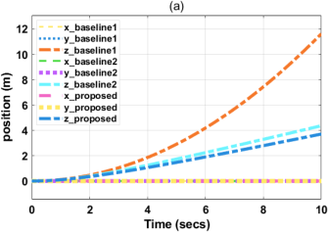
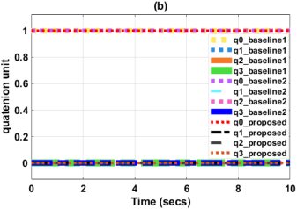
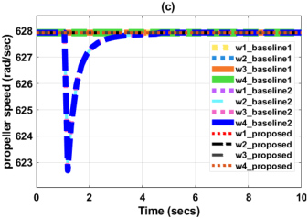
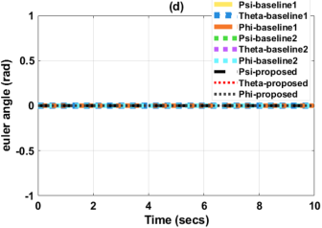
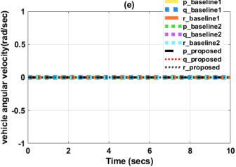

mainly due to the ground-effect term included in Baseline 2 but neglected in the
proposed model. In this study, ground effect was not considered because the main
focus was on free-flight trajectory tracking, where the quadrotor operates away
from the ground surface. Ground effect is most significant during near-ground
operations such as take-off and landing, and therefore its exclusion does not sig-
nificantly affect the intended trajectory tracking analysis. Furthermore, the close
agreement between the proposed model and Baseline 2 validates the effectiveness
of the introduced aerodynamic damping terms in capturing realistic quadrotor
flight behavior. This demonstrates that the proposed model preserves the es-
sential nonlinear dynamics required for reliable controller design and trajectory
tracking performance evaluation.
Figure 4.1: Quadrotor state for ascending maneuvering when U1 > mg
70

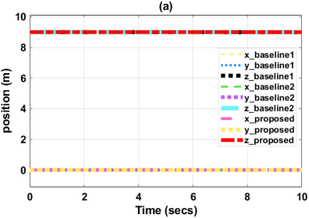
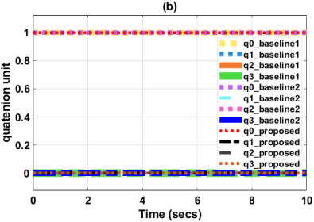
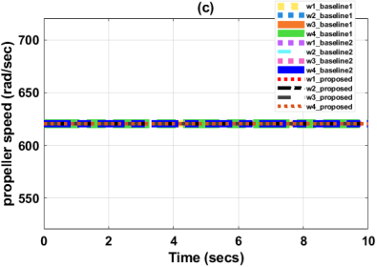
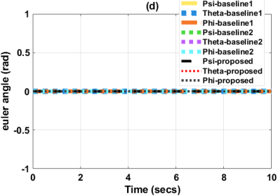
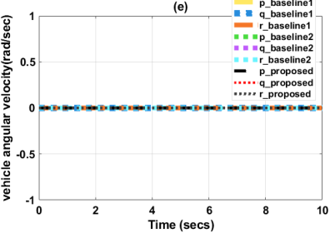

Hovering state: The quadrotor was initialized at an altitude of 9 m with the
total thrust set to U1 = 4.591 N, approximately equal to the vehicle weight. As
shown in Figure 4.2 (a), all models maintained a constant altitude with negligible
motion along the x- and y-axes, confirming stable hovering behavior. The pro-
peller speeds in Figure 4.2 (c) remained balanced, while the quaternion states, Eu-
ler angles, and angular velocities shown in Figures 4.2 (b), (d), and (e) remained
nearly constant. The proposed model closely matched Baseline 2, demonstrating
improved physical realism due to the inclusion of aerodynamic damping effects.
Figure 4.2: At Hovering state when U1 = mg
71

Roll rotation: At the hovering condition, a constant roll control torque of
U2 = 0.2 Nm was applied while maintaining a constant thrust input U1. This
maneuver was intended to evaluate the rotational behavior of the developed
quadrotor model under sustained roll excitation and to investigate the influence
of aerodynamic effects on the system dynamics. Figure 4.3 presents the responses
of the proposed model together with Baseline 1 and Baseline 2 under open-loop
conditions.
The position responses shown in Figure 4.3 (a) indicate that all models experience
increasing lateral displacement and substantial altitude loss once the roll torque
is applied. This behavior confirms the inherent instability of the quadrotor in
open-loop operation, where a continuous roll motion redirects part of the total
thrust away from vertical lift toward lateral motion. As the roll angle increases,
the vertical thrust component becomes insufficient to balance gravity, leading to
rapid descent along the z-axis.
However, the rate of altitude loss differs significantly among the models. Base-
line 1 exhibits the most aggressive response, with a much faster drop in alti-
tude and larger translational deviation. This occurs because the model neglects
translational aerodynamic drag and rotational damping torques, resulting in an
idealized dynamic response with minimal resistance to motion.
In contrast, the proposed model produces responses much closer to Baseline 2,
which is regarded as the more physically complete reference model.The inclu-
sion of translational drag coefficients (Cdx, Cdy, Cdz) and aerodynamic rotational
damping coefficients (Cap, Caq, Car) introduces dissipative effects that oppose ex-
cessive translational and rotational motion. Consequently, the proposed model
demonstrates smoother dynamic behavior and reduced instability growth com-
pared to Baseline 1.
Although Baseline 2 additionally incorporates the ground-effect term, the overall
responses of the proposed model remain in close agreement, confirming that aero-
dynamic drag and damping play a dominant role in capturing realistic quadrotor
72

rotational behavior.
The propeller speed responses shown in Figure 4.3 (c) clearly illustrate the mech-
anism responsible for roll generation. Two propellers increase their rotational
speeds while the opposite pair decreases speed, thereby creating the required
differential thrust to generate rolling motion about the body-frame x-axis. The
propeller responses remain balanced and physically consistent across all models,
confirming the correctness of the actuator dynamics implementation.
The quaternion trajectories in Figure 4.3 (b1)–(b3) progressively deviate from
their hovering equilibrium values, indicating increasing attitude displacement
from level flight.Similarly, the Euler angle responses in Figure 4.3 (d1)–(d3) show
continuous growth of the roll angle (ϕ), while the pitch (θ) and yaw (ψ) angles
remain comparatively small.
Baseline 1 exhibits severe oscillatory and rapidly diverging roll behavior, whereas
the proposed model and Baseline 2 demonstrate smoother rotational responses
because the aerodynamic damping terms dissipate rotational energy and suppress
excessive oscillations.Furthermore, the angular velocity responses shown in Fig-
ure 4.3 (e) confirm that the roll rate increases continuously during the maneuver,
while the pitch and yaw rates remain close to zero.
73

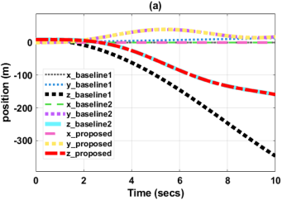
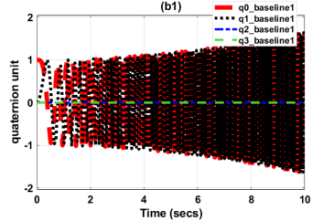
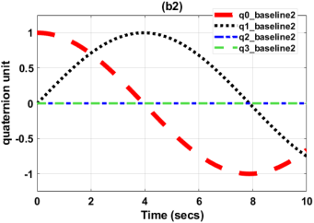
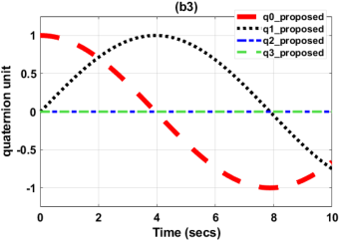
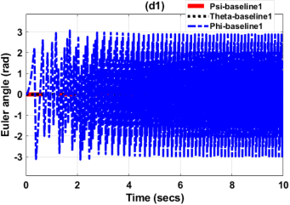
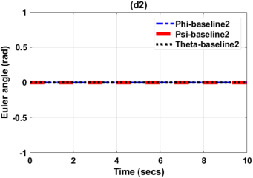
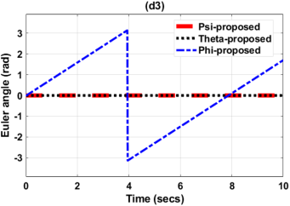
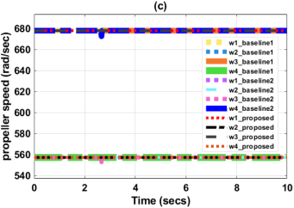
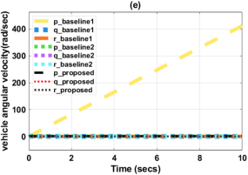

Figure 4.3: Roll rotation due to U1 = mg and U2 = 0.2 Nm
Pitch rotation: At the hovering condition, a constant pitch control torque of
74

U3 = 0.2 Nm was applied while maintaining a constant thrust input U1. This
maneuver was used to evaluate the pitch dynamics of the developed quadrotor
model under sustained rotational excitation. Figure 4.4 presents the responses
of the proposed model together with Baseline 1 and Baseline 2 under open-loop
conditions.
The position responses shown in Figure 4.4 (a) indicate that all models expe-
rience significant longitudinal displacement accompanied by rapid altitude loss
after the pitch torque is applied. As the quadrotor pitches forward, the thrust
vector tilts away from the vertical direction, reducing the upward force required
to balance gravity. Consequently, the vehicle descends while accelerating along
the longitudinal axis. Baseline 1 exhibits the fastest altitude loss and largest
translational displacement because aerodynamic drag and rotational damping
effects are neglected. The absence of these dissipative effects results in aggressive
and less realistic pitch dynamics.
In contrast, the proposed model produces responses much closer to Baseline 2 due
to the inclusion of translational drag and aerodynamic rotational damping terms.
These aerodynamic effects oppose excessive translational and rotational motion,
thereby moderating the pitch-induced instability and producing smoother and
more physically realistic responses.
The propeller speed responses shown in Figure 4.4 (c) confirm the differential
thrust mechanism responsible for pitch generation about the body-frame y-axis.
The quaternion trajectories in Figure 4.4 (b1)–(b3) progressively depart from
hovering equilibrium values, confirming increasing attitude deviation during the
maneuver.The Euler angle responses in Figure 4.4 (d1)–(d3) show dominant
growth of the pitch angle (ϕ), confirming rotational motion about the body-
frame y-axis. The roll angle (θ) and yaw angle (ψ) remained comparatively small
throughout the maneuver. Baseline 1 exhibited severe oscillatory and diverg-
ing pitch responses due to neglected aerodynamic damping, while the proposed
model and Baseline 2 produced smoother and more bounded behavior. Further-
75

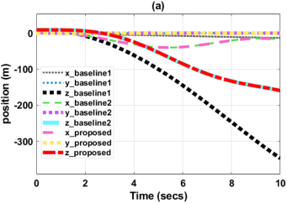
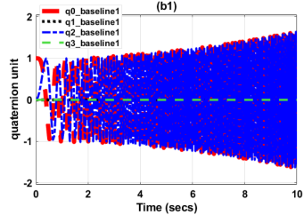
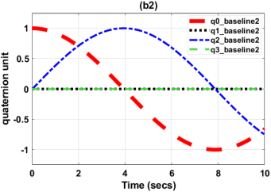
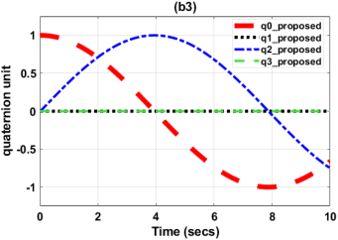
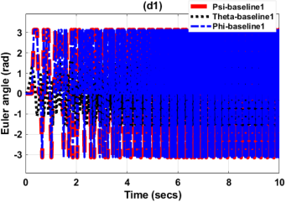
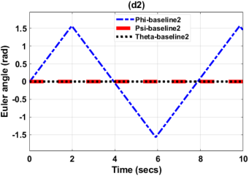
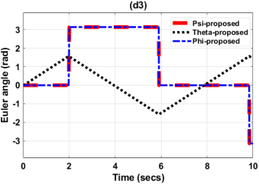
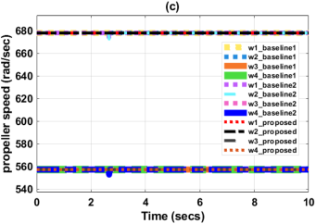
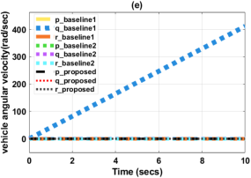

more, the angular velocity responses confirmed progressive increase of the pitch
rate, whereas the roll and yaw rates remained close to zero.
Figure 4.4: Pitch rotation due to U1 = mg and U3 = 0.2 Nm
76

Yaw rotation: At the hovering condition, a constant yaw control torque of
U4 = 0.2 Nm was applied while maintaining a constant thrust input U1. This
maneuver was used to evaluate the yaw rotational dynamics of the developed
quadrotor model under sustained rotational excitation. Figure 4.5 presents the
responses of the proposed model together with Baseline 1 and Baseline 2 under
open-loop conditions.
The position responses shown in Figure 4.5 (a) remain nearly constant throughout
the maneuver, with altitude preserved around 9 m and negligible displacement
along the x- and y-axes. This confirms that the applied yaw torque primarily
excites rotational motion about the body-frame z-axis without producing signifi-
cant translational motion. Unlike the roll and pitch maneuvers, the thrust vector
remains aligned with the vertical axis during yaw rotation, thereby maintaining
hover equilibrium and preventing substantial altitude loss.
The propeller speed responses shown in Figure 4.5 (c) exhibit the expected sep-
aration between counter-rotating motor pairs required to generate the reaction
torque responsible for clockwise yaw motion. The motor pairs rotating in op-
posite directions produce unequal drag torques, which collectively generate the
yawing moment about the vertical axis. The propeller responses remain smooth
and physically consistent for all models, confirming correct actuator behavior
during yaw excitation.
The quaternion trajectories in Figure 4.5 (b1)–(b3) vary smoothly and remain
bounded, confirming stable attitude representation during continuous heading
rotation. Similarly, the Euler angle responses in Figure 4.5 (d1)–(d3) show con-
tinuous growth of the yaw angle (ψ), while roll (θ) and pitch (ϕ) remain close to
zero, indicating decoupled rotational behavior. Baseline 1 exhibits more oscilla-
tory yaw responses because aerodynamic damping effects are neglected, whereas
the proposed model produces smoother rotational behavior closer to Baseline 2.
Furthermore, the angular velocity responses shown in Figure 4.5 (e) confirm
progressive increase of the yaw rate while the remaining angular rates stay near
77

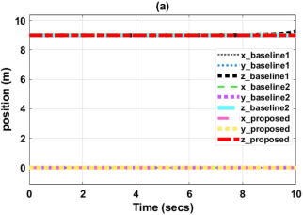
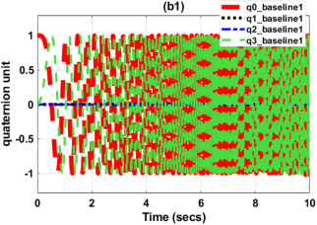
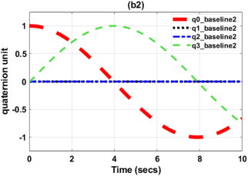
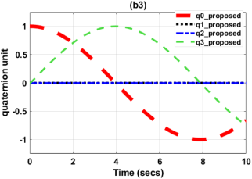
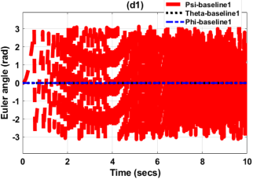
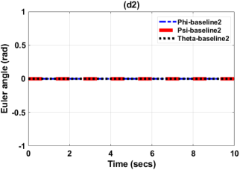
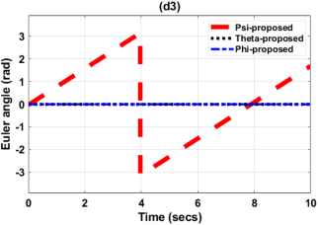
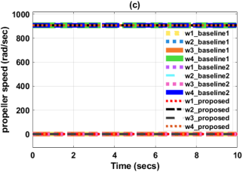
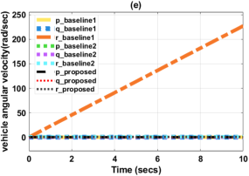

zero. Overall, the proposed model demonstrates close agreement with Baseline 2,
validating the effectiveness of the introduced aerodynamic terms in representing
realistic yaw rotational dynamics.
Figure 4.5: CW yaw rotation due to U1 = mg and U4 = 0.2 Nm
78

4.2 PSO tunning results
The results in Tables 4.1 and 4.2, together with Fig.4.6 and Fig.4.7, demon-
strate the effectiveness of PSO in tuning the ASTSMC gains in terms of Global
Best value (GBEST). For attitude control, a clear reduction in ITAE is observed
across all particle sizes, with faster convergence achieved at lower swarm sizes,
particularly Number of Particles (Nop) = 15, indicating computational efficiency
without compromising performance.
In contrast, position control shows minimal variation in final ITAE values, as all
configurations converge to a similar optimum, suggesting a well-defined solution
space.
Increasing particle size mainly affects convergence behavior rather than final
performance. Thus, PSO provides consistent and reliable tuning for both attitude
and position dynamics.
Table 4.1: PSO Performance for Different Numbers of Particles in Attitude Gains
Tuning
Nop | Iteration | Time (min) | 1st GBEST | 100th GBEST (%  improvement)
15 | 100 | 30 | 10.4968 | 7.6663 (26.97%)
30 | 100 | 86 | 10.3755 | 7.5522 (27.21%)
45 | 100 | 105 | 8.5419 | 7.6493 (10.45%)
60 | 100 | 136 | 8.5953 | 7.4569 (13.24%)
75 | 100 | 167 | 8.0127 | 7.6575 (4.43%)
Table 4.2: PSO Performance for Different Numbers of Particles in Position Gains Tun-
ing
Nop | Iteration | Time (min) | 1st GBEST | 100th GBEST (%  improvement)
15 | 100 | 38 | 64.1658 | 63.1375 (1.60%)
30 | 100 | 60 | 70.6404 | 63.1375 (10.63%)
45 | 100 | 67 | 63.6148 | 63.1375 (0.75%)
60 | 100 | 93 | 63.5962 | 63.1375 (0.72%)
75 | 100 | 105 | 63.5222 | 63.1375 (0.61%)
79

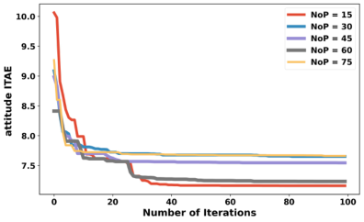
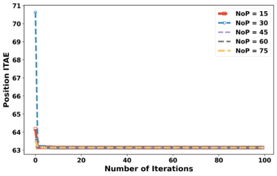

Figure 4.6: Attitude ITAE against Num- Figure 4.7: Position ITAE against Num-
ber of Iterations for different Particle ber of Iterations for different Particle
Swarm Size Swarm Size
4.3 Controller Evaluation Results
The simulation of designed quadcopter model was done in MATLAB/Simulink
environment. The quadcopter parameter used in the simulation is as shown
in Table 3.2. Simulation results created using Simulink give an insight about
performance of the designed controller, the controller’s initial gains were initially
tuned using a particle swarm optimization (PSO) approach, then after controller
gains were being tuned in real time by adaptive laws of adaptive super twisting
sliding mode controller.
Designed controller was tested in handling parameter variations and disturbances
without failing to track desired trajectories, then after spiral infinity, ramp helix
and square wave trajectory tracking was done to check its ability to follow desired
trajectory.
During parameter variation handling capacity and disturbance rejection the per-
formance was compared to Back Stepping Sliding Mode Controller (BTSMC)
[68] and conventional Proportional Integral Derivative controller (PID).
80

4.3.1 Parameter variation handling capacity
To demonstrate effectiveness and robustness of the designed controller in tracking
the desired trajectories under parameter variations, following desired trajectories
were used [9], [53]:
xd = 1 −cos(t), | yd = sin(t), | zd = t, | ψd = 0 | (4.1)
For the parametric variation analysis, the quadcopter mass was changed from
1 kg to 1.5 kg, representing a fixed 50% increase in mass. The mass remained
constant at 1.5 kg throughout the entire simulation period and was not varied
with time.
During this analysis, the inertia parameters along the x-, y-, and z-axes were
maintained constant in order to isolate the effect of mass variation on the quadro-
tor dynamic response. With reference to Figures 4.8–4.11, Figures 4.12–4.15, and
Table 4.3, the following observations was obtained.
Under 50% mass uncertainty, the three controllers exhibited different robust-
ness characteristics across the translational axes, indicating that each controller
possesses specific strengths and limitations. In the X-axis response, BTSMC
achieved the best tracking robustness with approximately 1% degradation,
while PID and ASTSMC showed about 40% and 58% degradation, respectively.
This indicates that BTSMC provided superior robustness in the longitudinal
tracking channel for the selected tuning conditions.
In the Y -axis response, however, the proposed ASTSMC demonstrated the best
performance, with only approximately 2% degradation compared to about 97%
degradation for BTSMC and 1% for PID. The result highlights the effectiveness
of the adaptive super twisting mechanism in compensating for model uncertainty
and maintaining lateral trajectory tracking under severe parameter variation.
For the altitude (Z)-axis response, BTSMC achieved the best robustness with
81

nearly negligible degradation, while PID exhibited moderate degradation of ap-
proximately 21%. In contrast, the proposed ASTSMC experienced larger degra-
dation of approximately 79%, indicating reduced robustness in the vertical control
channel under the selected adaptive tuning parameters.
The yaw response under 50% mass uncertainty showed that the proposed ASTSMC
experienced larger tracking degradation compared to BTSMC and PID con-
trollers. This indicates that, under the selected tuning parameters, the adaptive
mechanism was more focused on maintaining translational trajectory robustness
than precise yaw-angle regulation. Consequently, the controller tuning intro-
duced a trade-off between position tracking performance and yaw stabilization.
In contrast, BTSMC and PID achieved better yaw tracking performance under
the same operating conditions. However, the ASTSMC still maintained bounded
and stable system behavior without instability or divergence. Therefore, the
result does not imply failure of the proposed controller, but rather highlights the
influence of tuning priorities in multi-variable quadrotor control.
The observed yaw degradation also identifies an important area for future im-
provement, particularly in enhancing the adaptive yaw-channel gain tuning to
achieve more balanced translational and rotational tracking performance.
Table 4.3 shows that the proposed ASTSMC achieved approximately 35% reduc-
tion in thrust demand (U1) relative to the PID controller. This reduction still
demonstrates improved energy efficiency, which is important for battery-powered
UAV applications where minimizing control effort directly contributes to longer
flight endurance.
Although BTSMC achieved a lower thrust demand of approximately 29%, indi-
cating slightly better control effort minimization, the proposed ASTSMC pro-
vided a more balanced trade-off between robustness, adaptive capability, and
trajectory tracking performance under uncertain conditions.
82

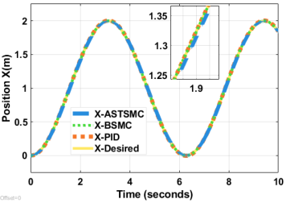
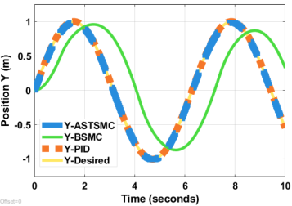
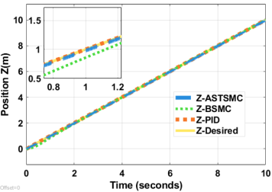
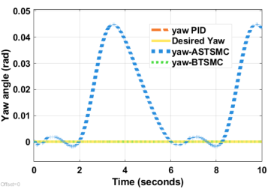

In particular, the adaptive gain mechanism of ASTSMC improved disturbance
rejection and maintained stable tracking performance under parameter varia-
tions, even though it required moderately higher thrust compared to BTSMC.
Therefore, the results suggest that the proposed method prioritizes robustness
and adaptability rather than solely minimizing control energy.
Although PID produced lower control torque variations, it does not actively com-
pensate for uncertainties or nonlinear effects. In contrast, the proposed ASTSMC
adaptively adjusted the control torques to preserve stable tracking under un-
certain conditions. Despite slightly higher torque demand in some channels,
ASTSMC achieved better robustness, disturbance rejection, and reliable flight
performance.
Figure 4.8: Position X tracking with para- Figure 4.9: Position Y tracking with para-
metric variation metric variation
Figure 4.10: | Position Z tracking with | Figure 4.11: Yaw tracking with paramet-
parametric variation ric variation
83

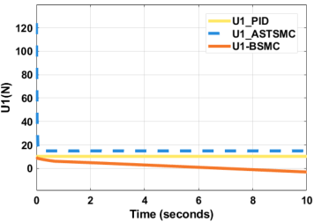
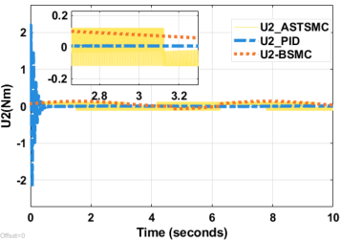
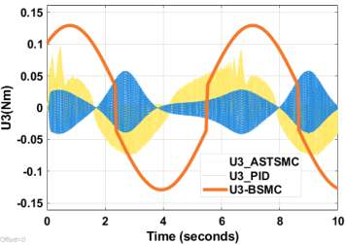
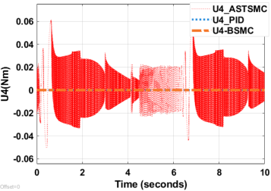

Figure 4.12: | Control input U1 during | Figure 4.13: | Control input U2 during
parametric variation parametric variation
Figure 4.14: | Control input U3 during | Figure 4.15: | Control input U4 during
parametric variation parametric variation
Table 4.3: ITAE values during parametric variation
 | ASTSMC | BTSMC | PID
X(m) | 0.2681(58%) | 0.006215(1%) | 0.1897(40%)
Y(m) | 0.525(2%) | 26.14(97%) | 0.1744(1%)
Z(m) | 1.401(79%) | 0.001363(0%) | 0.3756(21%)
yawerror(rad) | 0.4332(100%) | 0(0%) | 0(0%)
U1(N) | 9.98(35%) | 8.202(29%) | 10.23(36%)
U2(Nm) | 0.12(47%) | 0.1336(52%) | 0.002119(1%)
U3(Nm) | 0.03108(15%) | 0.1288(61%) | 0.0504(1%)
U4(Nm) | 0.03108(100%) | 0(0%) | 0(0%)

% Contributioni = | Vi | × 100 | (4.2)
% Contributioni = | VASTSMC + VBTSMC + VPID | × 100 | (4.2)
where Vi is the ITAE or control input value corresponding to a specific con-
troller, while VASTSMC, VBTSMC, and VPID represent the values obtained using
the ASTSMC, BTSMC, and PID controllers, respectively.
84

4.3.2 Disturbance rejection capacity
During this time mass of quadrotor was maintained at 1 kg, then a disturbance
of d = 1 −cos(t) was applied through all simulation time for x, y, z and yaw
dynamics, then we tested to see how the proposed controller could track these
desired trajectories,
xd = 1 −cos(t), | yd = sin(t), | zd = t, | ψd = 0 | (4.3)
With reference to Figures 4.16–4.19, Figures 4.20–4.23 and Table 4.5, following
insights were revealed.
An Adaptive Super Twisting Sliding Mode Controller (ASTSMC) demonstrated
strong disturbance rejection capability under continuous time-varying distur-
bances, achieving approximately 25%, 7%, and 20% ITAE degradation in the
X-, Y -, and Z-axes, respectively.
In contrast, the BTSMC experienced significantly larger degradation of approx-
imately 72% in the X-axis and 92% in the Y -axis, indicating reduced robust-
ness against external disturbances and model uncertainties. The PID controller
achieved lower ITAE values of approximately 3%, 1%, and 3% in the X-, Y -,
and Z-axes, respectively, reflecting effective disturbance attenuation under the
selected operating conditions.
For a fair comparison, controller convergence performance was evaluated quan-
titatively using the settling time criterion, defined as the time required for the
tracking error to enter and remain within a ±2% tolerance band around the
reference trajectory. The convergence times of ASTSMC, BTSMC, and PID in
Table 4.4 were obtained directly from the simulation responses using the same
evaluation criterion.
Although PID achieved lower ITAE values, the ASTSMC maintained stable
tracking performance under continuous disturbances while preserving the finite-
85

time convergence characteristics associated with higher-order sliding mode con-
trol approaches. Therefore, the comparison was based not only on tracking accu-
racy, but also on robustness and convergence behavior under uncertain operating
conditions.
Table 4.4: Approximate convergence times under disturbance
Axis | ASTSMC | BTSMC | PID
X-position | ≈0.8 s | ≈2.5 s | ≈0.7 s
Y-position | ≈0.9 s | No clear convergence | ≈0.8 s
Z-position | ≈1.0 s | ≈2.0 s | ≈0.9 s
The yaw response in Figure 4.19 shows that the proposed ASTSMC produced a
small bounded yaw deviation under disturbance, while BTSMC and PID main-
tained nearly zero yaw error.
This limitation is acknowledged. However, such yaw deviation may be acceptable
in position-critical UAV missions, for example environmental monitoring, crop
spraying, gas sensing, or package delivery to a fixed location, where maintaining
the desired x, y, and z trajectory is more important than maintaining exact
heading.
Since the yaw deviation remained bounded and did not destabilize the transla-
tional motion, the proposed ASTSMC remains suitable for missions where pay-
load orientation is not the primary requirement.
Although BTSMC achieved a slightly lower thrust input requirement (U1 =
8.202 N) compared to the proposed ASTSMC (U1 = 8.904 N), controller perfor-
mance cannot be evaluated based on thrust reduction alone. A fair comparison
should consider the overall closed-loop behavior, including trajectory tracking ac-
curacy, disturbance rejection, and stability across all translational and rotational
states.
From Table 4.5, BTSMC exhibited significantly larger ITAE values in the transla-
tional axes, particularly in the y-direction (45.35), compared to ASTSMC (3.513).
Similarly, BTSMC produced substantially larger control torques, especially in U3,
86

where it required 1.647 Nm compared to only 0.12 Nm for ASTSMC. This indi-
cates that BTSMC achieved lower thrust usage at the expense of larger control
effort and poorer trajectory regulation.
In contrast, the proposed ASTSMC provided a more balanced performance by
maintaining lower translational tracking errors, bounded yaw deviation, and
smoother control inputs under disturbance conditions. Therefore, the contri-
bution of ASTSMC is not merely thrust minimization, but achieving improved
robustness and overall control quality with moderate control effort under external
disturbances.
Although the PID controller achieved slightly lower values for U3 and U4, this does
not necessarily indicate superior overall performance. The lower torque demand
in these channels mainly suggests that PID applied less corrective action during
the disturbance period.
In contrast, the proposed ASTSMC actively compensated for external distur-
bances through the adaptive super twisting mechanism and disturbance observer,
resulting in slightly higher, but still smooth and bounded, torque inputs.
More importantly, ASTSMC maintained chattering-free control signals and avoided
the excessive torque spikes observed in BTSMC, particularly in U3, where BTSMC
required 1.647 Nm compared to only 0.12 Nm for ASTSMC.
Therefore, while PID shows lower control effort in U3 and U4, the proposed
ASTSMC provides a more balanced compromise between disturbance rejection,
robustness, actuator safety, and control smoothness. Hence, the superiority of
ASTSMC should not be judged from individual torque components alone, but
from the overall closed-loop performance under disturbance conditions.
87

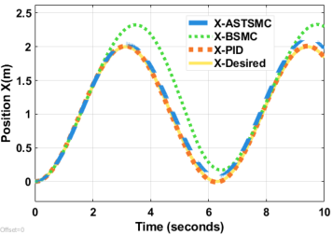
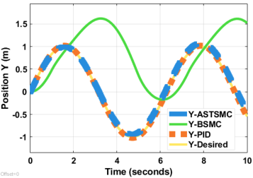
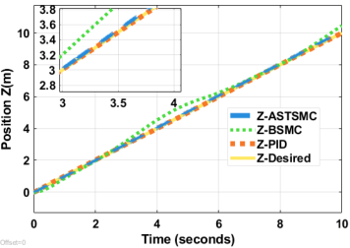
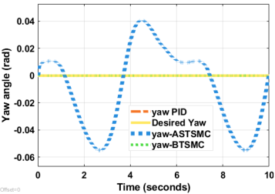

Figure 4.16: Position X tracking with dis- Figure 4.17: Position Y tracking with dis-
turbance turbance
Figure 4.18: Position Z tracking with dis- | Figure 4.19: | Yaw tracking with distur-
turbance bance
Figure 4.20: Control input U1 during dis- Figure 4.21: Control input U2 during dis-
turbance turbance
Figure 4.22: Control input U3 during dis- Figure 4.23: Control input U4 during dis-
turbance turbance
88

Table 4.5: ITAE values during disturbance rejection
 | ASTSMC | BTSMC | PID
X(m) | 3.968(25%) | 11.26(72%) | 0.4989(3%)
Y(m) | 3.513(7%) | 45.35(92%) | 0.6096(1%)
Z(m) | 3.002(20%) | 11.34(77%) | 0.4357(3%)
yawerror(rad) | 0.01466(100%) | 0(0%) | 0(0%)
U1(N) | 8.904(33%) | 8.202(30%) | 10.21(37%)
U2(Nm) | 0.12(5%) | 0.1693(7%) | 2.1(88%)
U3(Nm) | 0.12(7%) | 1.647(91%) | 0.04235(2%)
U4(Nm) | 0.1082(21%) | 0.3986(79%) | 0(0%)
4.3.3 Spiral infinity trajectory tracking
Figure 4.24–4.34 illustrates the spiral infinity trajectory tracking performance of
the quadrotor under the ASTSMC scheme. The desired trajectory is defined as
xd = 1 −cos(t), yd = 0.5 sin(2t), zd = t, and ψd = 0, generating a spiral infinity
path with continuous altitude variation. The ASTSMC controller demonstrated
exceptional tracking performance across the spiral infinity trajectory.
In Figure 4.24–4.26 position tracking showed remarkable precision, with x-axis
oscillations maintaining peak amplitudes near 2 m with minimal overshoot and
y-axis tracking exhibiting tight convergence within ±0.6 m bounds throughout
the 30 second flight. The z-axis achieved near perfect linear ascent from 0 to
30 m, with the actual trajectory overlaying the desired path almost identically.
The 3D visualization in Figure 4.34 confirmed excellent spatial tracking, where
the green desired trajectory and red actual path remained closely intertwined
despite the complex spiral geometry.
Attitude control proved equally robust as shown in Figure 4.27–4.29. Roll angles
tracked sinusoidal references between ±3 radian with negligible steady-state er-
ror, while pitch maintained oscillations within ±0.1 rad with smooth transitions.
Yaw tracking exhibited the most dynamic behavior, with deviations remaining
within ±0.05 rad during rapid directional changes. This deviation range was
89

considered acceptable because it remained sufficiently small to preserve trajectory
stability and attitude synchronization throughout the maneuver.
In quadrotor flight control literature, attitude tracking errors below ±0.05 rad
are commonly regarded as an indication of good tracking precision and stable
closed-loop performance under aggressive maneuvers.
For instance, in [69] reported that orientation tracking errors maintained within
±0.05 rad for roll, pitch, and yaw demonstrated satisfactory controller effective-
ness and trajectory tracking accuracy in quadrotor systems.
Therefore, the observed yaw deviation in the proposed ASTSMC remained within
an acceptable control tolerance for nonlinear trajectory tracking applications.Control
effort analysis revealed efficient actuation: U1 stabilized at approximately 20 N
after initial transients, U2 oscillated between ±0.15 N · m matching trajectory
demands, while U3 and U4 remained bounded within ±0.1 N · m, indicating well
tuned gains without excessive chattering or saturation hallmarks of practical im-
plementability.
90

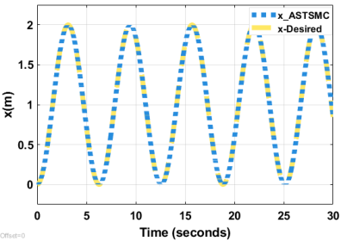
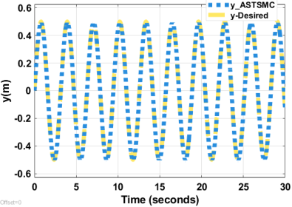
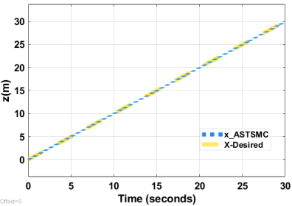
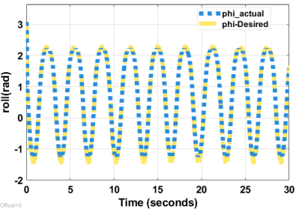
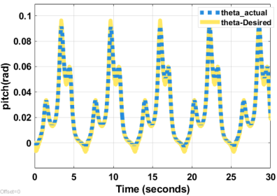
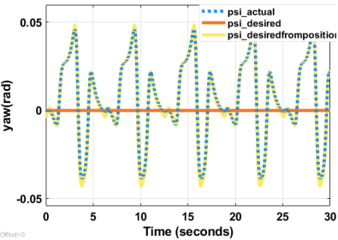

Figure 4.24: | Spiral Infinity X Position | Figure 4.25: | Spiral Infinity Y Position
Tracking Tracking
Figure 4.26: | Spiral Infinity Z Position | Figure 4.27: | Spiral Infinity Roll Angle
Tracking Tracking
Figure 4.28: Spiral Infinity Pitch Angle | Figure 4.29: | Spiral Infinity Yaw Angle
Tracking tracking
91

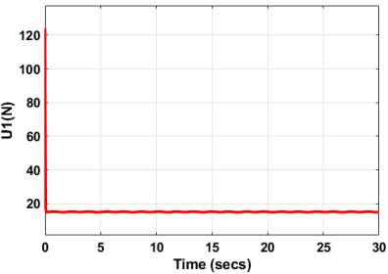
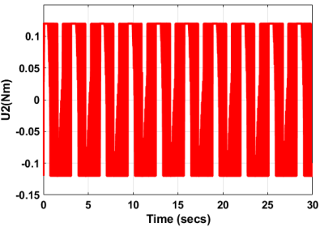
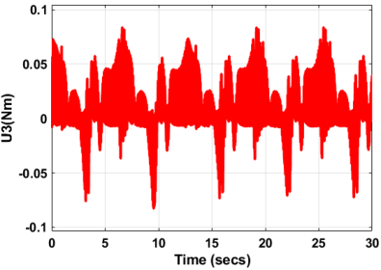
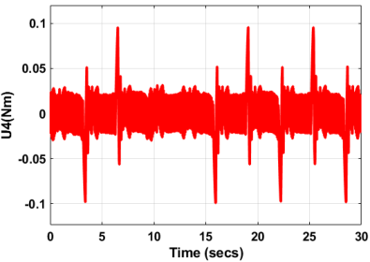
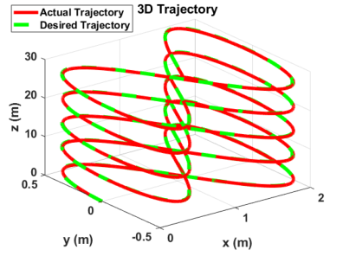

Figure 4.30: Control input U1 for Spiral Figure 4.31: Control input U2 for Spiral
Infinity trajectory Infinity trajectory
Figure 4.32: Control input U3 for Spiral Figure 4.33: Control input U4 for Spiral
Infinity trajectory Infinity trajectory
Figure 4.34: Spiral Infinity 3D Position
Tracking
92

4.3.4 Ramp helix trajectory tracking
The simulation results in Fig. 4.35–4.45 demonstrate the effectiveness of the
ASTSMC controller in tracking a ramp helix trajectory defined by xd = 1−cos(t),
yd = 1 −cos(t), zd = t, and ψd = sin(t).
The ASTSMC controller demonstrated excellent tracking performance for the
challenging ramp helix trajectory. Position tracking in Fig 4.35–4.37 showed re-
markable accuracy across all axes: x-position maintained tight oscillatory track-
ing with deviations under 0.15 m, while y-position exhibited similar precision
with maximum errors around 0.2 m. The z-position tracking was particularly
impressive, following the linear ascent from 0 to 30 m with negligible steady-state
error below 0.1 m. The 3D trajectory visualization in Figure 4.45 confirmed that
the actual path closely matched the desired helical ascent, with the quadcopter
successfully executing the spiraling climb pattern.
In Figure 4.38–4.40 attitude control proved equally robust. Roll angle tracking
achieved accuracy within ±0.05 rad throughout the maneuver, while pitch angles
stayed within ±0.1 rad of reference values. Yaw tracking displayed smooth sinu-
soidal behavior with errors consistently below 0.08 rad, demonstrating effective
orientation control during the complex spiral motion.
Control effort analysis revealed reasonable actuator demands in Figure 4.41–4.44.
Input U1 maintained steady thrust around 100 N for altitude gain, while U2 and
U4 exhibited moderate oscillations (±0.1 N · m) corresponding to roll and yaw
corrections. U3 showed slightly higher activity (±0.05 N · m) managing pitch
dynamics. The control signals remained smooth without chattering, indicating
that the adaptive super-twisting mechanism effectively handled trajectory com-
plexities while maintaining practical implementation feasibility.
93

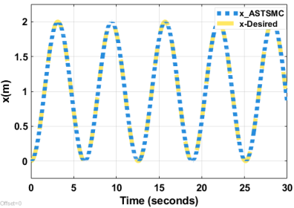
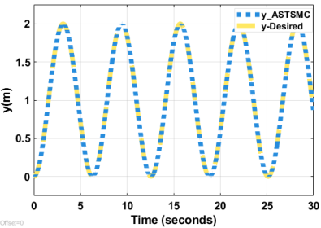
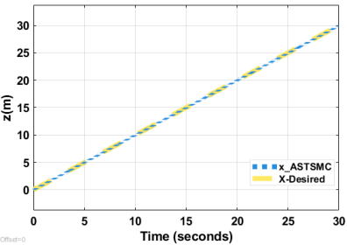
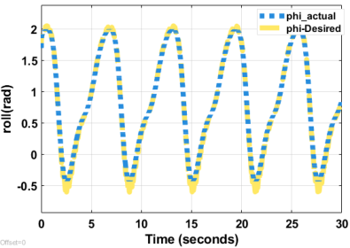
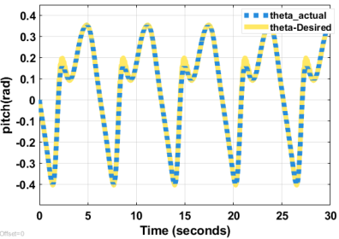
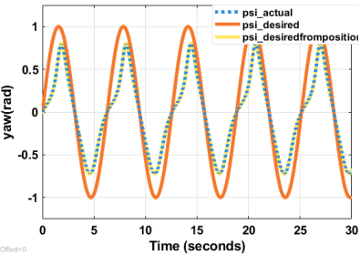

Figure 4.35: | Ramp Helix X Position | Figure 4.36: | Ramp Helix Y Position
Tracking Tracking
Figure 4.37: | Ramp Helix Z Position | Figure 4.38: | Ramp Helix Roll Angle
Tracking Tracking
Figure 4.39: | Ramp Helix Pitch Angle | Figure 4.40: Ramp Helix wave tracking
Tracking | Ramp Helix Pitch Angle | Figure 4.40: Ramp Helix wave tracking
94

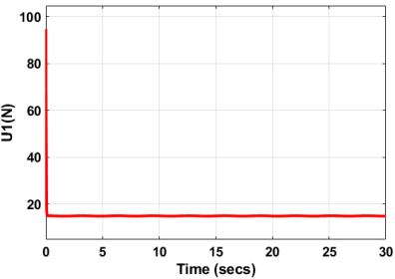
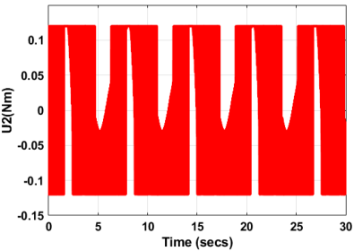
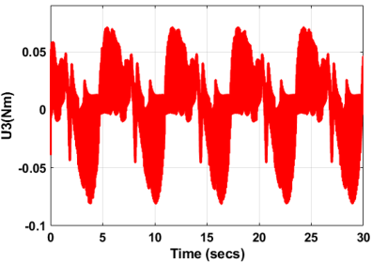
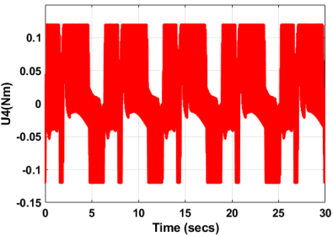
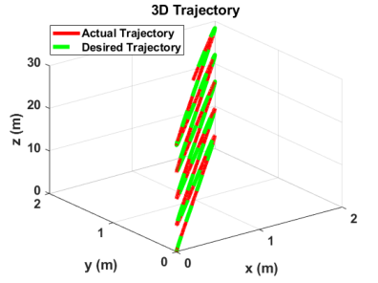

Figure 4.41: Control input U1 for Ramp Figure 4.42: Control input U2 for Ramp
Helix trajectory Helix trajectory
Figure 4.43: Control input U3 for Ramp Figure 4.44: Control input U4 for Ramp
Helix trajectory Helix trajectory
Figure 4.45: Ramp Helix 3D Position
Tracking
95

4.3.5 Square wave trajectory trajectory tracking
The ASTSMC demonstrated excellent tracking performance for the square wave
trajectory across all axes. From the trajectory plots, the controller achieved
rapid convergence with settling times under 2 seconds and maintained steady-
state errors below 0.5 cm throughout the 30 second flight.
The x and y position tracking in Figure 4.46 and Figure 4.47 showed minimal
overshoot during transitions, while the z-axis in Figure 4.48 exhibited a slightly
more aggressive response due to gravitational coupling. The 3D visualization in
Figure 4.56 confirms tight adherence to the reference path, and the yaw angle in
Figure 4.51 tracked the step changes with negligible lag.
Regarding control effort, the input signals reveal the adaptive algorithm’s ef-
fectiveness in mitigating chattering. While in Figure 4.52, U1 (thrust) shows
expected high frequency components during transitions,In Figures 4.53–4.54 the
U2, U3, and U4 (moment controls) display significantly smoother profiles com-
pared to conventional sliding mode controllers.
The peak control magnitudes remained within practical actuator limits U1 peaked
at approximately 1000 N equivalent, while the moment inputs stayed below
0.1 N · m. Notably, the chattering amplitude decreased progressively after each
transition, suggesting that the adaptive gains successfully tuned themselves to
the system dynamics, balancing robustness with control smoothness.
96

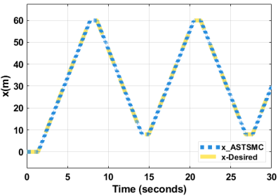
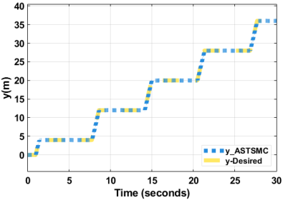
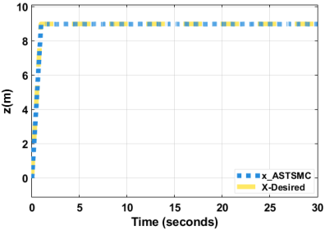
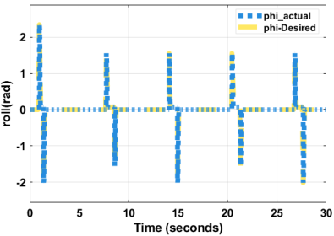
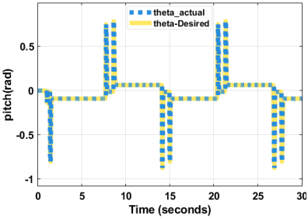
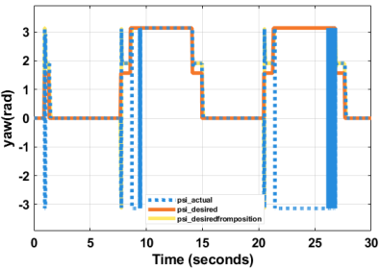

Figure 4.46: | Square wave X Position | Figure 4.47: | Square wave Y Position
Tracking Tracking
Figure 4.48: | Square wave Z Position | Figure 4.49: | Square wave Roll Angle
Tracking Tracking
Figure 4.50: | Square wave Pitch Angle | Figure 4.51: Yaw Square wave tracking
Tracking | Square wave Pitch Angle | Figure 4.51: Yaw Square wave tracking
97

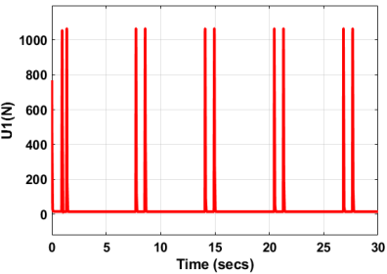
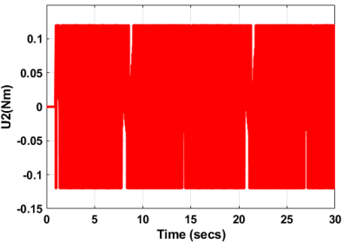
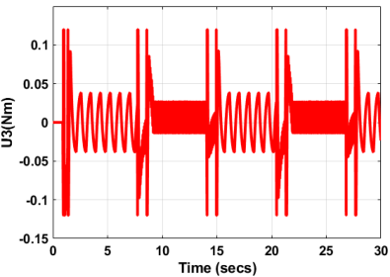
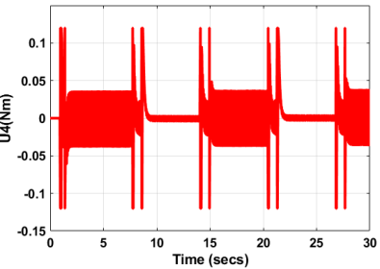
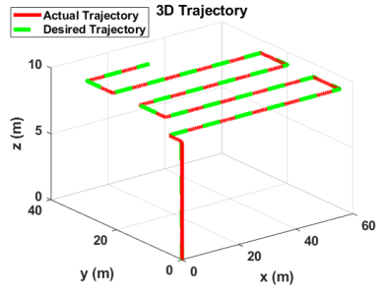

Figure 4.52: Control input U1 for square Figure 4.53: Control input U2 for square
wave trajectory wave trajectory
Figure 4.54: Control input U3 for square Figure 4.55: Control input U4 for square
wave trajectory wave trajectory
Figure 4.56: Square wave 3D Position
Tracking
98

CHAPTER 5
CONCLUSION &
RECOMMENDATIONS
5.1 Conclusion
This research addressed the problem of trajectory tracking for quadrotor UAVs
operating under nonlinear dynamics, parameter uncertainties, and external dis-
turbances. Existing controllers such as PID are simple to implement but ex-
hibit limited robustness under model variations, while conventional sliding mode
controllers often suffer from chattering and difficult gain tuning. To overcome
these limitations, this study developed a Particle Swarm Optimization (PSO)
tuned Adaptive Super Twisting Sliding Mode Controller (ASTSMC) based on a
quaternion-formulated quadrotor model.
The first objective of this study was to develop a quaternion-based mathemat-
ical model for quadrotor dynamics. The derived model successfully represented
both translational and rotational dynamics without the singularity problems as-
sociated with Euler-angle formulations. In addition, the model incorporated
aerodynamic drag and disturbance effects, making it more suitable for realistic
flight analysis and controller design. The study further demonstrated that the
quaternion formulation provides smooth attitude representation during aggres-
sive maneuvers, which is important for practical UAV applications.
The second objective was to design an adaptive super twisting sliding mode
controller for trajectory tracking. The developed ASTSMC achieved accurate
99

attitude and position tracking while significantly reducing the chattering com-
monly observed in conventional sliding mode control. Simulation results showed
that the controller maintained stable tracking performance even under severe
disturbances and parameter uncertainties, including a 50% increase in quadrotor
mass. Compared to the benchmark controllers, the proposed controller produced
lower tracking errors with smoother control signals, confirming its robustness and
adaptability.
The third objective was to optimize controller parameters using Particle Swarm
Optimization. The integration of PSO enabled systematic and automatic tuning
of controller gains, eliminating the need for time-consuming manual adjustment.
The optimized ASTSMC improved attitude tracking accuracy by approximately
27% and position tracking accuracy by about 9% compared to the benchmark
methods. Furthermore, the overall performance index, which combined trajec-
tory tracking accuracy and control effort, was reduced by approximately 28–30%,
indicating improved controller performance with lower actuator demand.
The major scientific contribution of this research lies in the integration of quaternion-
based quadrotor modeling, adaptive super twisting sliding mode control, and
PSO-based gain optimization into a unified trajectory tracking framework. Un-
like many existing studies that rely on Euler-angle representations or manually
tuned controllers, this work demonstrated that combining quaternion dynamics
with intelligent optimization improves robustness, reduces chattering, and en-
hances tracking performance under uncertain operating conditions.
In terms of real-time applicability, the proposed controller is suitable for practi-
cal implementation on modern embedded flight-control hardware. Although the
ASTSMC structure is computationally more complex than classical PID con-
trol due to the adaptive laws and PSO-based tuning stage, the online control
algorithm mainly involves algebraic operations that can be executed within prac-
tical sampling times on processors such as STM32, ESP32, or Pixhawk-based
platforms. In this work, PSO optimization was performed offline; therefore, it
100

does not impose additional computational burden during real-time flight opera-
tion. This makes the proposed approach computationally feasible for real-time
quadrotor control applications.
5.2 Recommendations
Although the proposed PSO-based Adaptive Super Twisting Sliding Mode Con-
troller demonstrated strong trajectory tracking performance in simulation, fur-
ther work is needed to enhance its practical relevance. Future studies should
prioritize real-time experimental implementation on an actual quadrotor plat-
form in order to confirm the controller’s effectiveness under real operating condi-
tions, where sensor noise, actuator limitations, and environmental disturbances
are unavoidable. It is also recommended that more advanced disturbance esti-
mation or intelligent adaptation techniques, such as neural networks, be explored
to improve performance under fast-changing uncertainties.
101

REFERENCES
[1] J. Peksa and D. Mamchur, “A review on the state-of-the-art in copter drones
and flight control systems,” Sensors, vol. 24, no. 11, p. 3349, 2024.
[2] K. Karam, A. Mansour, M. Khaldi, B. Clement, and M. Ammad-Uddin,
“Quadcopters in smart agriculture: Applications and modelling,” Applied
Sciences, vol. 14, no. 19, p. 9132, 2024.
[3] L. Criollo, C. Mena-Arciniega, and S. Xing, “Classification, military appli-
cations, and opportunities of unmanned aerial vehicles,” Aviation, vol. 28,
no. 2, pp. 115–127, 2024.
[4] R. S. Geronel, G. R. Begnini, R. M. Botez, and D. D. Bueno, “An overview
on the use of unmanned aerial vehicles for medical product transportation:
flight dynamics and vibration issues,” Journal of the Brazilian Society of
Mechanical Sciences and Engineering, vol. 44, no. 8, p. 349, 2022.
[5] J. Shah, M. Okasha, and W. Faris, “Gain scheduled integral linear quadratic
control for quadcopter,” Int J Eng Technol, vol. 7, no. 4.13, pp. 81–85, 2018.
[6] S. Bushra, H. Memon, A. Nighat, and B. Chowdhry, “Design of robust &
predictive controller for altitude stabilization and trajectory tracking of a
quad-copter,” International Journal of Engineering & Technology, vol. 7,
no. 4.38, pp. 416–421, 2018.
[7] A. Eltayeb, M. F. Rahmat, and M. A. M. Basri, “Sliding mode control design
for the attitude and altitude of the quadrotor UAV,” International Journal
on Smart Sensing and Intelligent Systems, vol. 13, no. 1, pp. 1–13, 2020.
[8] R. Elagib and A. Karaarslan, “Sliding mode control-based modeling and
simulation of a quadcopter,” J. Eng. Res. Rep, vol. 24, no. 3, pp. 32–41,
2023.
102

[9] N. B. Abera, C. M. Abdissa, and L. N. Lemma, “An improved nonsingular
adaptive super twisting sliding mode controller for quadcopter,” Plos One,
vol. 19, no. 10, p. e0309098, 2024.
[10] J. Colmenares-V´azquez, N. Marchand, J.-E. Gomez-Balderas, P. Castillo,
J. J. T´ellez-Guzm´an, J. ´Alvarez-Mu˜noz, and J. Dumon, “Position control
of a quadrotor under external constant disturbance,” in 2015 Workshop on
Research, Education and Development of Unmanned Aerial Systems (RED-
UAS). IEEE, 2015, pp. 180–185.
[11] J. Colmenares-Vazquez, N. Marchand, P. Castillo, J.-E. Gomez-Balderas,
J. Alvarez-Munoz, and J. J. T´ellez-Guzm´an, “Integral backstepping control
for trajectory tracking of a hybrid vehicle,” in 2015 International Conference
on Unmanned Aircraft Systems (ICUAS). IEEE, 2015, pp. 209–217.
[12] A. Jebelli, A. Najafiyanfar, A. Mahabadi, and M. C. Yagoub, “Fault tol-
erance of a quadrotor via feedback linearization approach,” IAES Int. J.
Robot. Autom, vol. 12, pp. 228–239, 2023.
[13] A. Jafar, S. Ahmad, and N. Ahmed, “Mathematical modeling and control
law design for 1dof quadcopter flight dynamics,” in 2016 International Con-
ference on Computing, Electronic and Electrical Engineering (ICE Cube).
IEEE, 2016, pp. 79–84.
[14] W. D. N. Silva and T. da Silva Castro, “Modelagem matem´atica de
quadric´opteros atrav´es da an´alise de sistemas dinˆamicos no espa¸co de
estados-mathematical modeling of quadrotor based in space of states analy-
sis of dynamic system,” Multiverso: Revista Eletrˆonica do Campus Juiz de
Fora-IF Sudeste MG, vol. 3, p. 232, 2018.
[15] A. Mokhtari and A. Benallegue, “Dynamic feedback controller of euler an-
gles and wind parameters estimation for a quadrotor unmanned aerial vehi-
cle,” in IEEE International Conference on Robotics and Automation, 2004.

Proceedings. ICRA’04. 2004, vol. 3. IEEE, 2004, pp. 2359–2366.
103

[16] S. K. Mohan, A. R. Davidson, and D. Mishra, “Reinforcement learning based
attitude control of quadcopter,” in 2024 Tenth Indian Control Conference
(ICC). IEEE, 2024, pp. 520–525.
[17] C. Acosta Lua, C. C. Vaca Garcia, S. Di Gennaro, B. Castillo-Toledo, and
M. E. Sanchez Morales, “Real-time hovering control of unmanned aerial ve-
hicles,” Mathematical Problems in Engineering, vol. 2020, no. 1, p. 2314356,
2020.
[18] A. Alaimo, V. Artale, C. Milazzo, and A. Ricciardello, “Comparison between
euler and quaternion parametrization in UAV dynamics,” in AIP Conference
Proceedings, vol. 1558, no. 1. American Institute of Physics, 2013, pp. 1228–
1231.
[19] G. E. M. Abro, S. A. B. Zulkifli, and V. S. Asirvadam, “Performance evalu-
ation of newton euler & quaternion mathematics-based dynamic models for
an underactuated quadrotor UAV,” in 2021 11th IEEE international con-
ference on control system, computing and engineering (ICCSCE). IEEE,
2021, pp. 142–147.
[20] S. Seshasayanan and S. R. Sahoo, “Robust linear controller design for tilt
quadrotor based on euler angles,” in 2022 Eighth Indian Control Conference
(ICC). IEEE, 2022, pp. 218–223.
[21] R. Hedjar and M. A. Al Zuair, “Robust altitude stabilization of vtol-UAV
for payloads delivery,” IEEE Access, vol. 7, pp. 73 583–73 592, 2019.
[22] H. L. N. N. Thanh, T. T. Huynh, M. T. Vu, N. X. Mung, N. N. Phi, S. K.
Hong, and T. N. L. Vu, “Quadcopter UAVs extended states/disturbance
observer-based nonlinear robust backstepping control,” Sensors, vol. 22,
no. 14, p. 5082, 2022.
[23] B. Roy, A. Dey, and J. Dey, “Design of sliding mode control law for quadrotor
with adaptive super twisting algorithm,” in AI and Blockchain Optimization
104

Techniques in Aerospace Engineering. IGI Global Scientific Publishing,
2024, pp. 76–111.
[24] N. P. Nguyen, N. X. Mung, H. L. N. N. Thanh, T. T. Huynh, N. T. Lam,
and S. K. Hong, “Adaptive sliding mode control for attitude and altitude
system of a quadcopter UAV via neural network,” IEEE Access, vol. 9, pp.
40 076–40 085, 2021.

[25] W. R. Hamilton, Elements of quaternions. London: Longmans, Green, &
Company, 1866.
[26] E. Fresk and G. Nikolakopoulos, “Full quaternion based attitude control for
a quadrotor,” in 2013 European control conference (ECC). IEEE, 2013, pp.
3864–3869.
[27] E. Fresk, “Modeling, control and experimentation of a variable pitch quadro-
tor,” Master’s thesis, Lund University, Lund, Sweden, 2013.
[28] M. E. Guerrero-Sanchez, H. Abaunza, P. Castillo, R. Lozano, and C. D.
Garc´ıa-Beltr´an, “Quadrotor energy-based control laws: a unit-quaternion
approach,” Journal of Intelligent & Robotic Systems, vol. 88, no. 2, pp.
347–377, 2017.
[29] A. Yazdanshenas and R. Faieghi, “Quaternion-based sliding mode control
for six degrees of freedom flight control of quadrotors,” in 2024 IEEE/RSJ
International Conference on Intelligent Robots and Systems (IROS). IEEE,
2024, pp. 10 385–10 390.
[30] A. Shevidi and H. A. Hashim, “Quaternion-based adaptive backstepping fast
terminal sliding mode control for quadrotor UAVs with finite time conver-
gence,” Results in Engineering, vol. 23, p. 102497, 2024.
[31] H. Sun, J. Li, R. Wang, and K. Yang, “Attitude control of the quadro-
tor UAV with mismatched disturbances based on the fractional-order slid-
ing mode and backstepping control subject to actuator faults,” Fractal and
Fractional, vol. 7, no. 3, p. 227, 2023.
105

[32] P. E. Pounds, D. R. Bersak, and A. M. Dollar, “Stability of small-scale UAV
helicopters and quadrotors with added payload mass under PID control,”
Autonomous Robots, vol. 33, pp. 129–142, 2012.
[33] S. Abdelhay and A. Zakriti, “Modeling of a Quadcopter Trajectory Tracking
System Using PID Controller,” Procedia Manufacturing, vol. 32, pp. 564–
571, 2019.
[34] G. E. M. Abro, A. M. Abdallah, and M. E. Elshaar, “Swarm coordination
and trajectory tracking in quadrotor UAVs using fractional-order PID con-
trol strategy,” IEEE Transactions on Automation Science and Engineering,
2025.
[35] S. Samy, Z. Al Wareh, and A. El-Badawy, “Robust adaptive nonsingular fast
terminal sliding mode control for tracking aggressive quadrotor trajectories,”
in 2024 6th Novel Intelligent and Leading Emerging Sciences Conference
(NILES). IEEE, 2024, pp. 274–279.
[36] M. Labbadi and M. Cherkaoui, “Novel robust super twisting integral sliding
mode controller for a quadrotor under external disturbances: M. labbadi,
m. cherkaoui,” International Journal of Dynamics and Control, vol. 8, no. 3,
pp. 805–815, 2020.
[37] O. Mofid, S. Mobayen, and W.-K. Wong, “Adaptive terminal sliding mode
control for attitude and position tracking control of quadrotor UAVs in the
existence of external disturbance,” IEEE access, vol. 9, pp. 3428–3440, 2020.
[38] J. Wang, B. Zhu, and Z. Zheng, “Robust adaptive control for a quadro-
tor UAV with uncertain aerodynamic parameters,” IEEE Transactions on
Aerospace and Electronic Systems, vol. 59, no. 6, pp. 8313–8326, 2023.
[39] J. Pan and J. Xiong, “Robust dual-channel disturbance rejection attitude
control for a quadrotor UAV: Theory and experiment,” 2021.
[40] F. Ahmad, P. Kumar, A. Bhandari, and P. P. Patil, “Simulation of the quad-
copter dynamics with LQR based control,” Materials Today: Proceedings,
106

vol. 24, pp. 326–332, 2020.
[41] A. Minervini, S. Godio, G. Guglieri, F. Dovis, and A. Bici, “Development
and validation of a LQR -based quadcopter control dynamics simulation
model,” Journal of Aerospace Engineering, vol. 34, no. 6, p. 04021095, 2021.
[42] R. B. Anderson, J. A. Marshall, and A. L’Afflitto, “Constrained robust
model reference adaptive control of a tilt-rotor quadcopter pulling an un-
modeled cart,” IEEE Transactions on Aerospace and Electronic Systems,
vol. 57, no. 1, pp. 39–54, 2020.
[43] M. Kashi, G. A. Hazareh, and H. Ghadiri, “Finite-time adaptive robust
nonlinear control for uncertain quadrotor UAV carrying a load under exter-
nal disturbances,” Journal of Vibration and Control, p. 10775463251346070,
2025.
[44] E. A. Gedefaw, C. M. Abdissa, and L. N. Lemma, “An improved trajectory
tracking control of quadcopter using a novel sliding mode control with fuzzy
PID surface,” PloS one, vol. 19, no. 11, p. e0308997, 2024.
[45] J. Zhao, Z. Xie, M. Xiao, F. Xu, and Z. Gao, “A sliding mode control algo-
rithm based on improved super-twisting and its application to quadrotors,”
Journal of Control and Decision, vol. 10, no. 3, pp. 433–442, 2023.
[46] H. Sang, F. Zheng, F. Huang, and S. Zhang, “Quadrotor UAV trajectory
tracking control based on adaptive non-singular terminal sliding mode,” J.
Electr. Syst, vol. 20, no. 3, pp. 929–939, 2024.
[47] N. Ahmed and S. A. Ali Shah, “Adaptive output-feedback robust active
disturbance rejection control for uncertain quadrotor with unknown distur-
bances,” Engineering Computations, vol. 39, no. 4, pp. 1473–1491, 2022.
[48] A. M. Aghazamani and M. Khodabandeh, “Fault-tolerant adaptive frac-
tional order sliding mode control for a quadrotor using disturbance ob-
server,” Journal of Control and Decision, vol. 11, no. 4, pp. 689–706, 2024.
107

[49] N. Mohidem, S. Jaafar, R. Rosle, N. Che’Ya, J. A. Shah, W. F. Ilahi,
W. Zainol, Z. Berahim, M. Omar, and M. Ismail, “Application of multi-
spectral UAV for paddy growth monitoring in jitra, kedah, malaysia,” in
IOP Conference Series: Earth and Environmental Science, vol. 1038, no. 1.
IOP Publishing, 2022, p. 012053.
[50] M. Akhil, M. K. Anand, A. Sreekumar, and P. Hithesan, “Simulation of
the mathematical model of a quad rotor control system using MATLAB
Simulink,” Applied Mechanics and Materials, vol. 110, pp. 2577–2584, 2012.
[51] G. Alemaw and G. Agegnehu, “Precision agriculture and the need to intro-
duce in ethiopia,” Ethiopian Journal of Agricultural Sciences, vol. 29, no. 3,
pp. 139–158, 2019.
[52] Y. Y. Lv, W. Huang, J. Liu, and Z. F. Peng, “A sliding mode controller
of quadrotor based on unit quaternion,” Applied Mechanics and Materials,
vol. 536, pp. 1087–1092, 2014.
[53] M. M. Madebo, C. M. Abdissa, L. N. Lemma, and D. S. Negash, “Ro-
bust tracking control for quadrotor UAV with external disturbances and
uncertainties using neural network based MRAC,” Ieee Access, vol. 12, pp.
36 183–36 201, 2024.
[54] O. Doukhi, A. R. Fayjie, and D. J. Lee, “Intelligent controller design for
quad-rotor stabilization in presence of parameter variations,” Journal of
Advanced Transportation, vol. 2017, no. 1, p. 4683912, 2017.
[55] L. Baoying, L. Mingqiu, and Y. Junwei, “Research on pose control of quad-
rotor UAV based on sliding mode active disturbance rejection,” in Proceed-
ings of the 2020 4th International Conference on Electronic Information
Technology and Computer Engineering, 2020, pp. 663–668.
[56] R. W. Beard, “Quadrotor dynamics and control,” Brigham Young Univer-
sity, vol. 19, no. 3, pp. 46–56, 2008.
108

[57] J. M. Selfridge and G. Tao, “A multivariable adaptive controller for a
quadrotor with guaranteed matching conditions,” Systems Science & Con-
trol Engineering: An Open Access Journal, vol. 2, no. 1, pp. 24–33, 2014.
[58] C. Bensalah, N. K. M’Sirdi, and A. Naamane, “Full modelling and sliding
mode control for a quadrotor UAV in visual servoing task,” in IMAACA2019,
2019.
[59] N. Ahmed and M. Chen, “Sliding mode control for quadrotor with distur-
bance observer,” Advances in Mechanical Engineering, vol. 10, no. 7, p.
1687814018782330, 2018.
[60] D. D. C. Bernard, F. Riccardi, M. Giurato, and M. Lovera, “A dynamic
analysis of ground effect for a quadrotor platform,” IFAC-PapersOnLine,
vol. 50, no. 1, pp. 10 311–10 316, 2017.
[61] S. R. Nekoo, J. ´A. Acosta, and A. Ollero, “Quaternion-based state-
dependent differential riccati equation for quadrotor drones: Regulation
control problem in aerobatic flight,” Robotica, vol. 40, no. 9, pp. 3120–3135,
2022.
[62] M. Schreier, “Quaternion-based adaptive attitude control schemes for
quadrotor systems,” International Journal of Mechatronics and Automa-
tion, vol. 3, no. 4, pp. 217–229, 2013.
[63] Z. Li, X. Ma, and Y. Li, “Model-free control of a quadrotor using adap-
tive proportional derivative-sliding mode control and robust integral of the
signum of the error,” International Journal of Advanced Robotic Systems,
vol. 15, no. 5, pp. 1–15, 2018.
[64] N. El Gmili, M. Mjahed, A. El Kari, and H. Ayad, “Particle swarm optimiza-
tion based proportional-derivative parameters for unmanned tilt-rotor flight
control and trajectory tracking,” Automatika, vol. 61, no. 2, pp. 189–206,
2020.
109

[65] T. Blackwell, J. Kennedy, and R. Poli, “Particle swarm optimization,”
Swarm Intelligence, vol. 1, no. 1, pp. 33–57, 2007.
[66] L. Besnard, Y. B. Shtessel, and B. Landrum, “Control of a quadrotor ve-
hicle using sliding mode disturbance observer,” in 2007 American Control
Conference. IEEE, 2007, pp. 5230–5235.
[67] T. Bresciani, “Modelling, identification and control of a quadrotor heli-
copter,” MSc theses, 2008.
[68] H. Bouadi, M. Bouchoucha, and M. Tadjine, “Sliding mode control based
on backstepping approach for an UAV type-quadrotor,” World Academy of
Science, Engineering and Technology, vol. 26, no. 5, pp. 22–27, 2007.
[69] Q. T. Pham, T. H. Nguyen, and D. V. Le, “Adaptive sliding mode control
for quadrotor uav trajectory tracking under external disturbances,” Applied
Sciences, vol. 14, no. 6, p. 2414, 2024.
110

